**Lab 6 VPN**

**Task 1 : Network Setup**

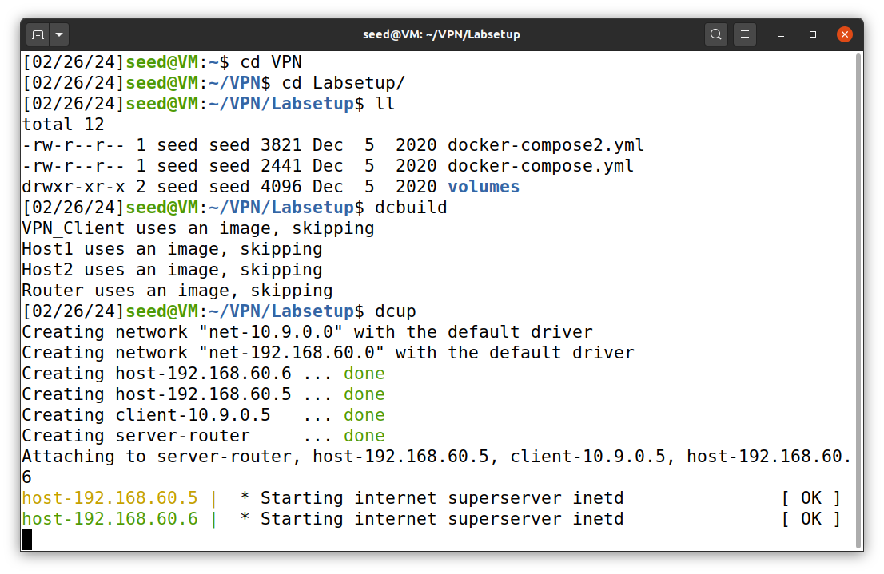In this task we setup the environment for the VPN Lab. So first as usual I build the docker file and start the docker containers.

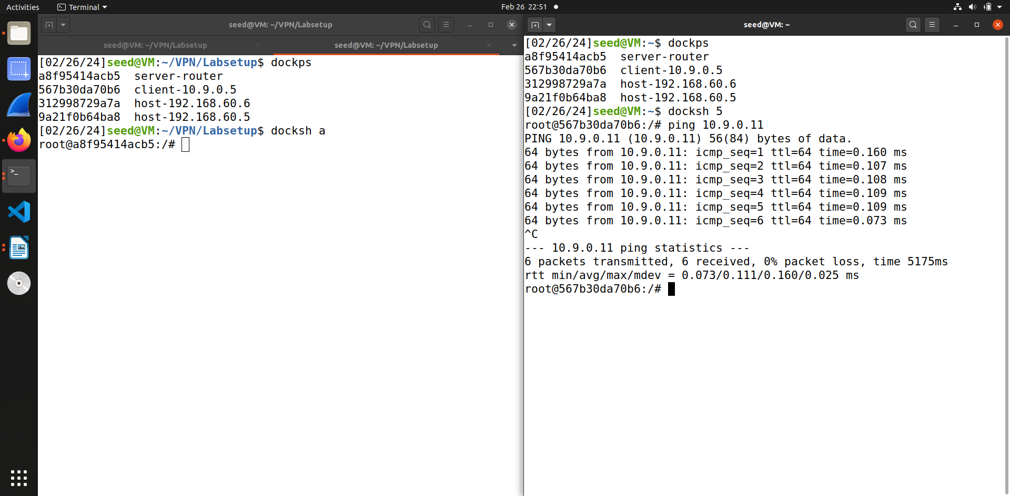The first test is to check if host U can communicate with VPN server. To perform this docksh in Host U – 10.9.0.5 and then ping server – 10.9.0.11 , which works.

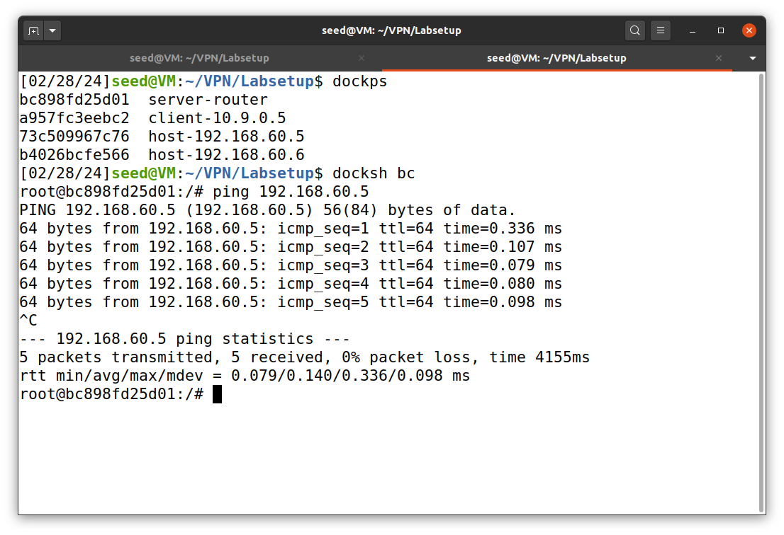This is the second test in which we test if VPN server can communicate with Host V. For this I docksh into VPN server – 10.9.0.11 and then ping host V – 192.168.60.5, this is also successful.

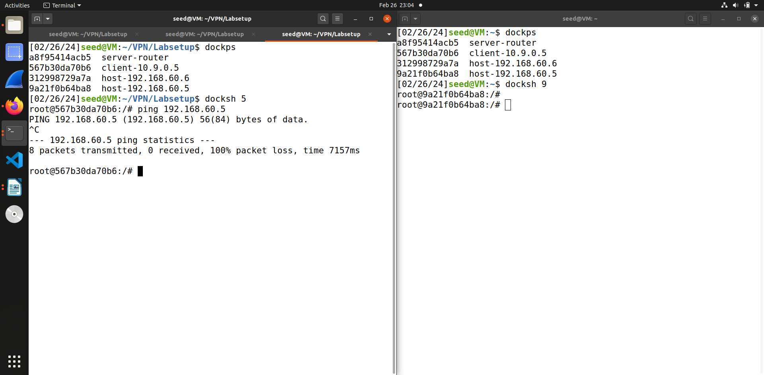The next test is to check if Host U shouldn’t be able to communicate with Host V. To perform this I docksh in host U – 10.9.0.5 and ping host V – 192.168.60.5 , as you can see through screenshot this fails.

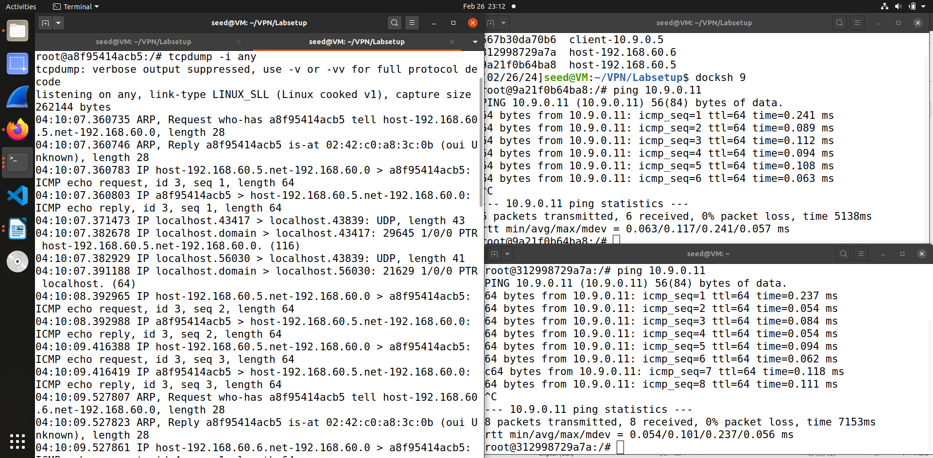The last test is to run tcpdump on router and sniff the traffic on each of the network. To execute this I ping the server router – 10.9.0.11 from both hosts that are - 10.9.0.5 & 192.168.60.5 and then run tcpdump to capture the packets.

**Task 2 : Create and Configure TUN interface**

**Task 2.a : Name of the interface**

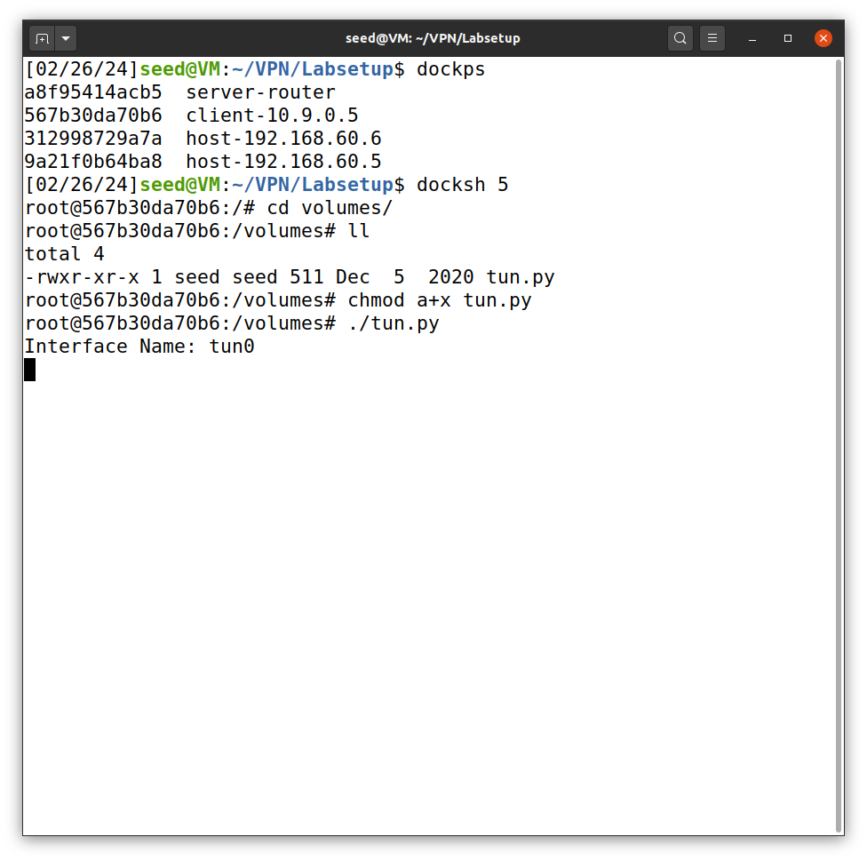So in this task first we docksh the Host U – 10.9.0.5 and then give executable privileges to tun.py and then execute it.

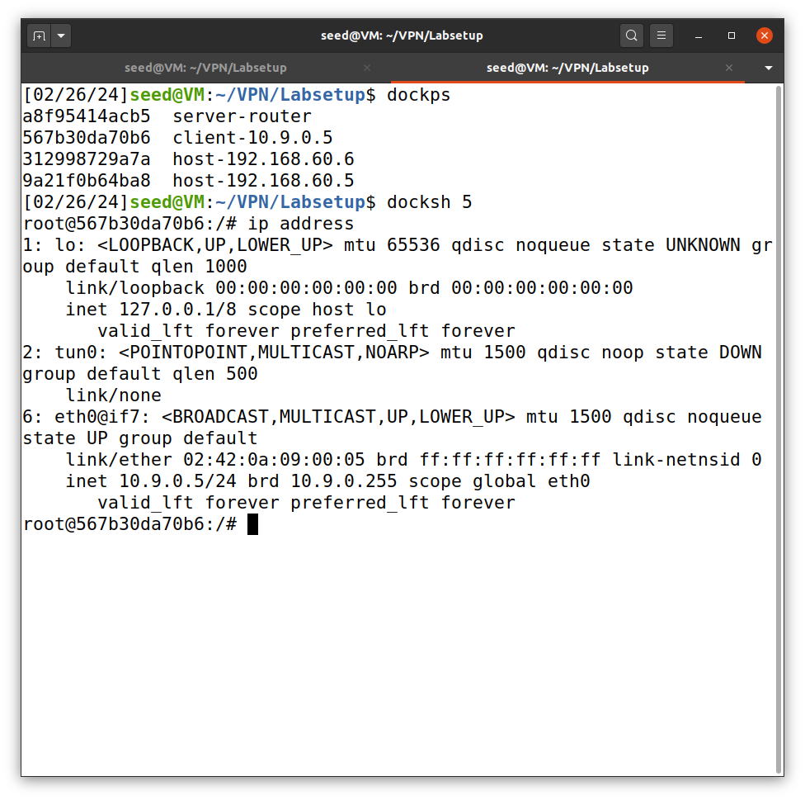As you can see from above screenshot after running the tun.py, the new interface tun0 is created, which we are able to see when we run command ip address.

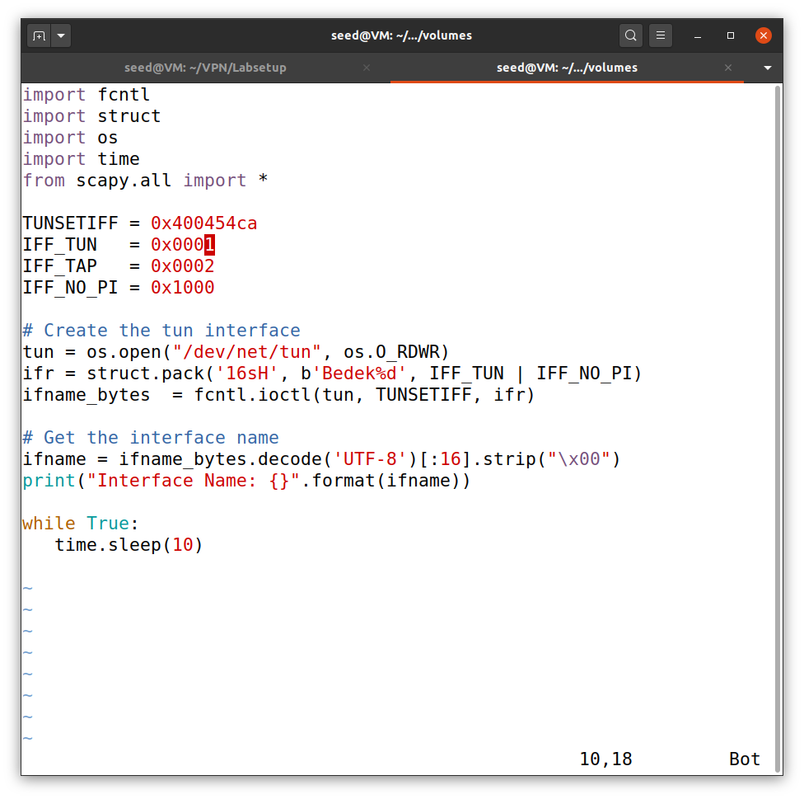So the task is to modify the tun.py code and replace the tun0 with 5 letters of my surname. So the above screenshot is shows I have change interface name to Bedek

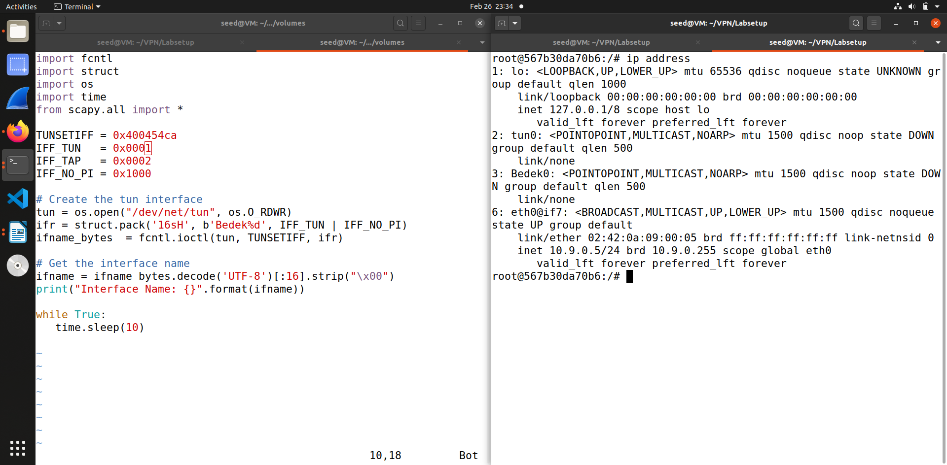So when I run the code again you can see through the screenshot that the new interface generated is called Bedek0, which is the list of of interfaces.

**Task 2.b : Set up the TUN interface**

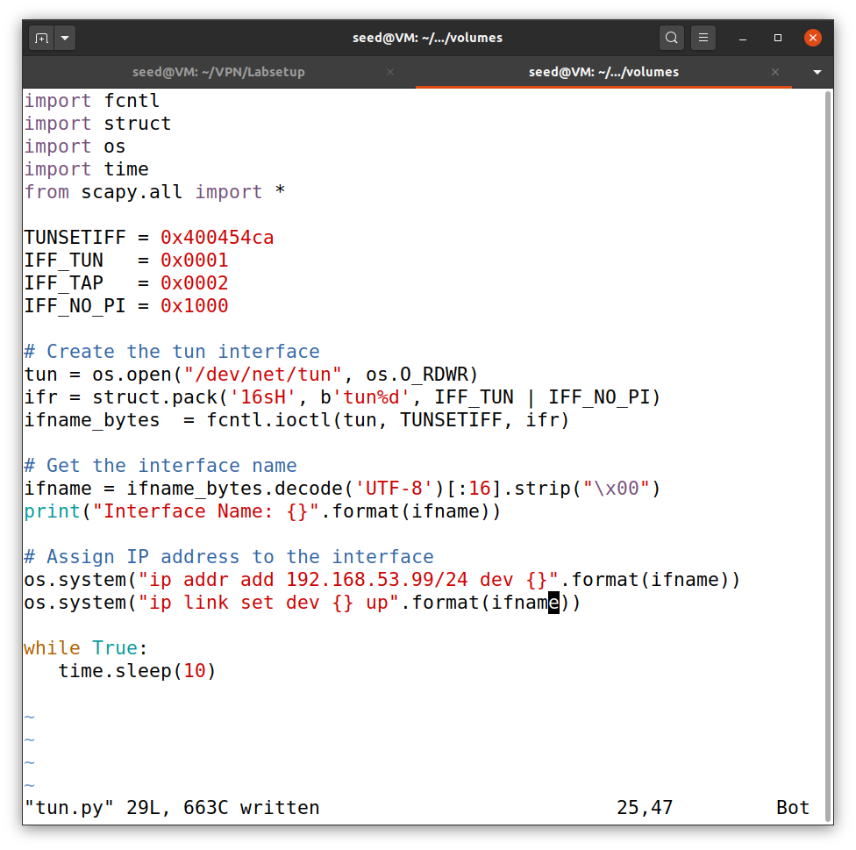In this task we set up the TUN interface and assign IP address to interface so this the modified code for that.

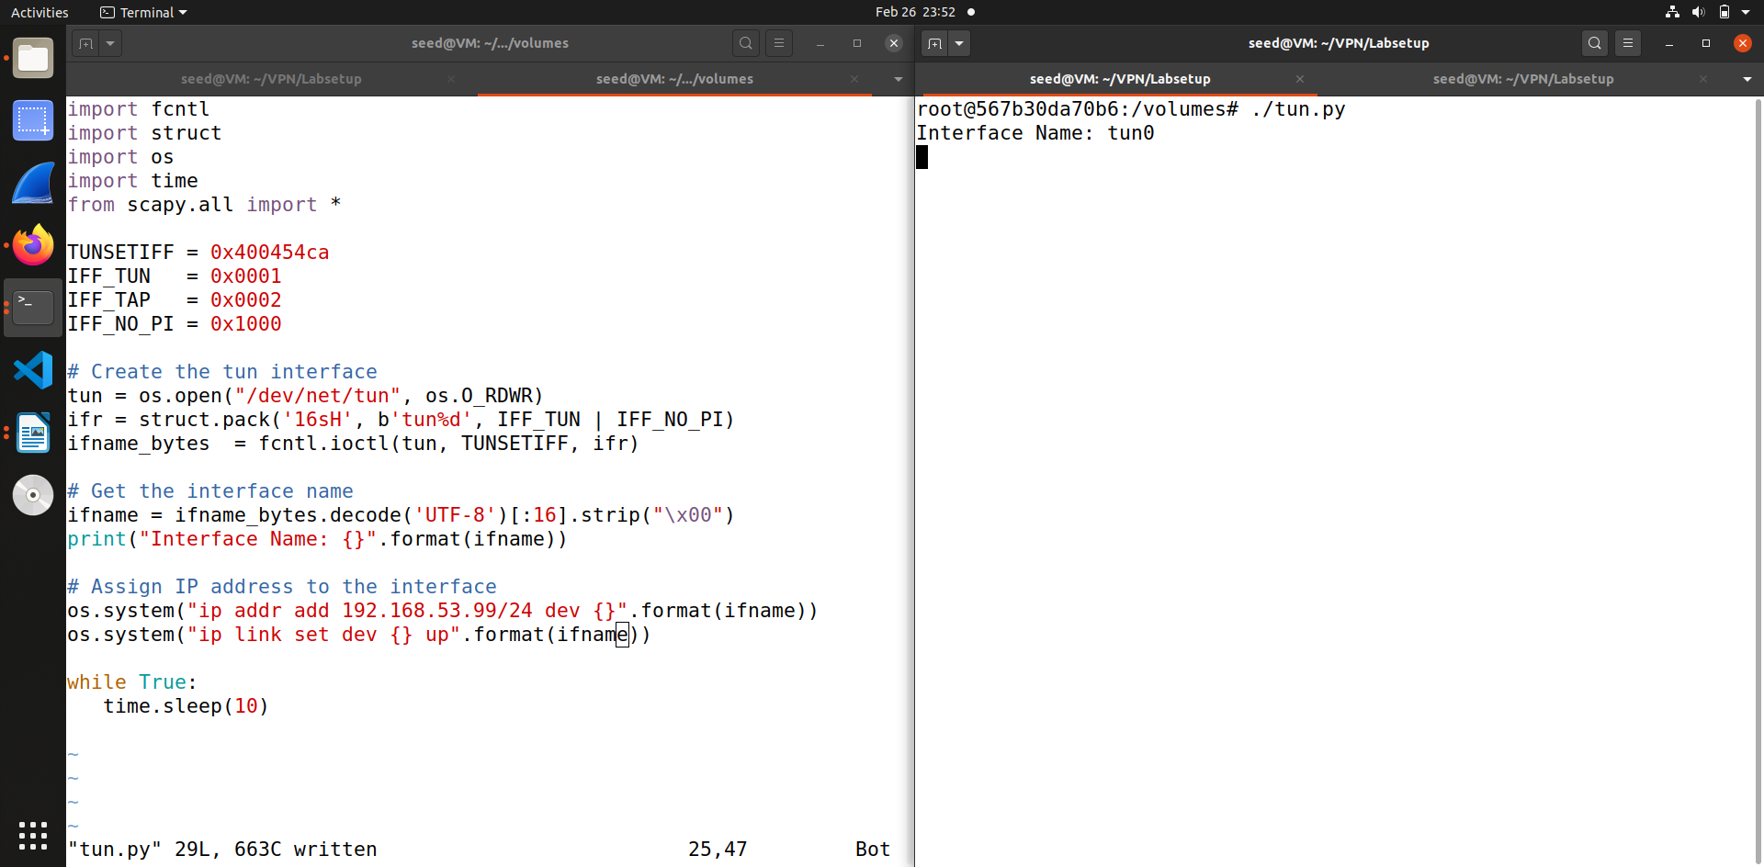So once again we run the modified code.

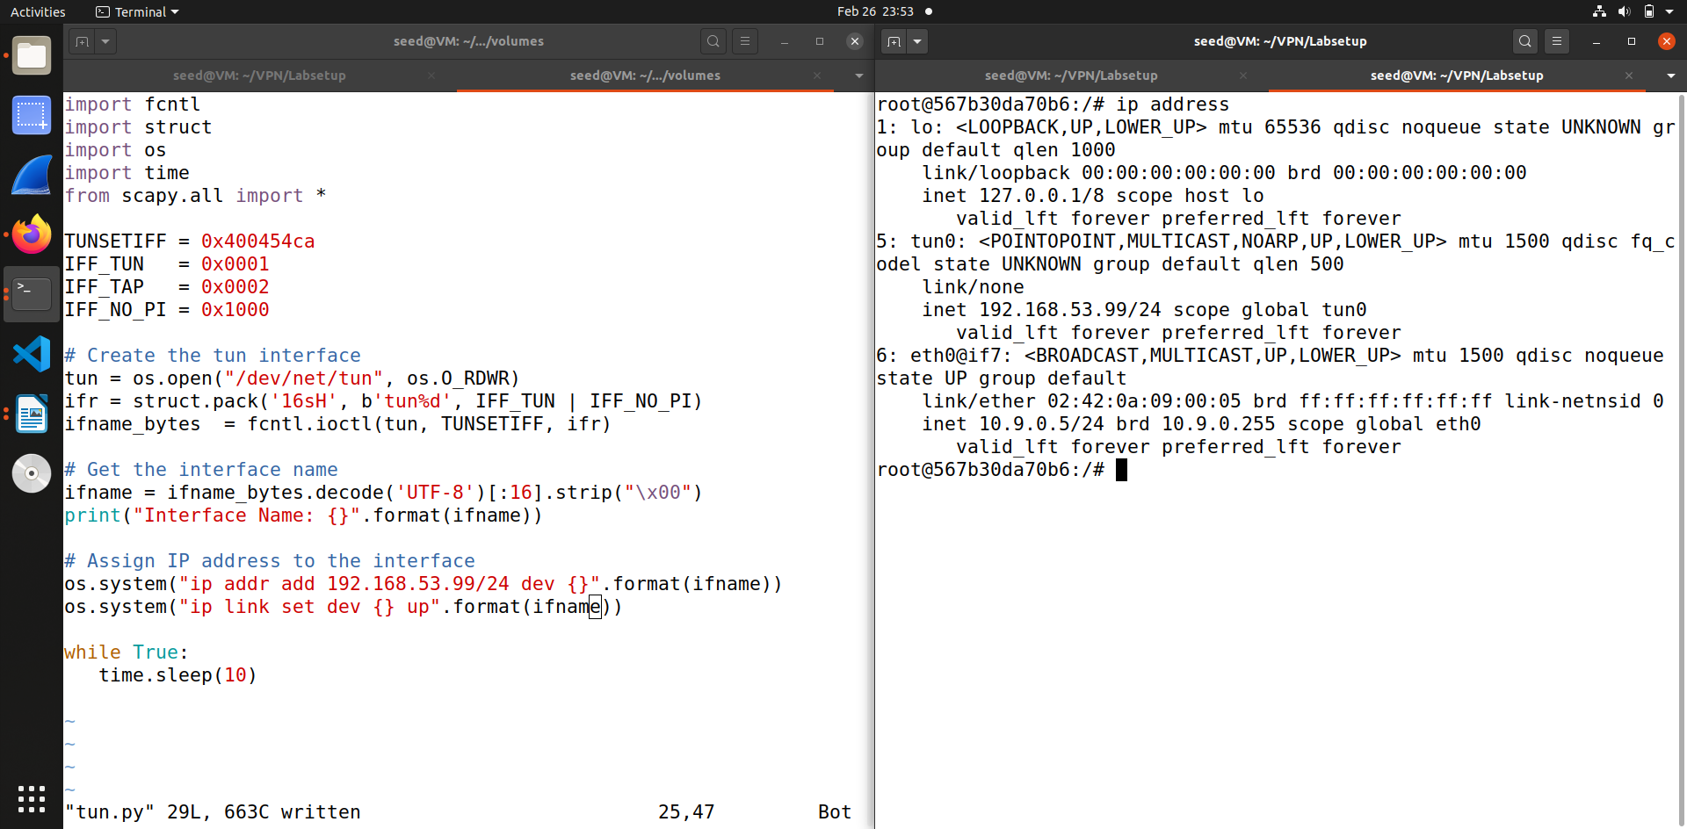When we check the list of interfaces we can see that tun0 is visible and if you check the previous screenshot and compare you can see that the state is changed from DOWN to UNKNOWN.

**Task 2.c : Read from the TUN interface**

In this task we read from the tun interface, for this once again we have to modify the code.

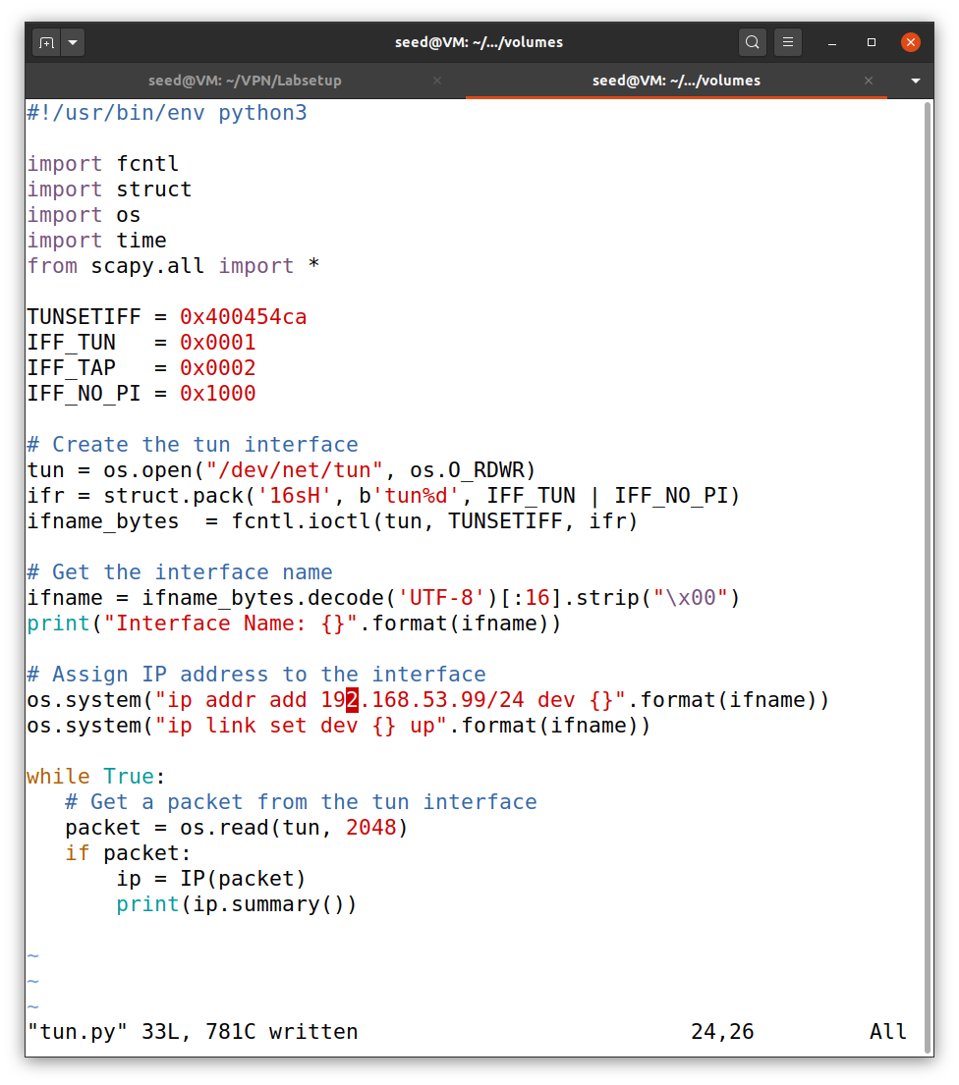So this the modified code for the task.

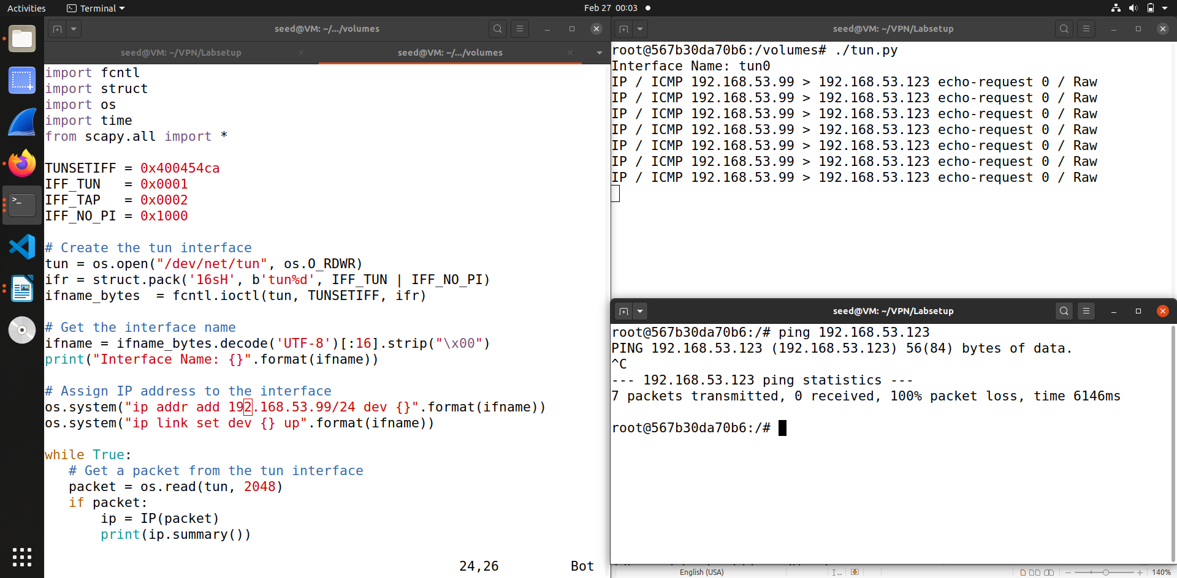Now we need to ping any host in the internal network – 193.168.53.0/24, so I tried to ping 192.168.53.123. So as you can see in tun interface it starts to sniff the packets, as it setup and assigned the IP address of 192.163.53.99

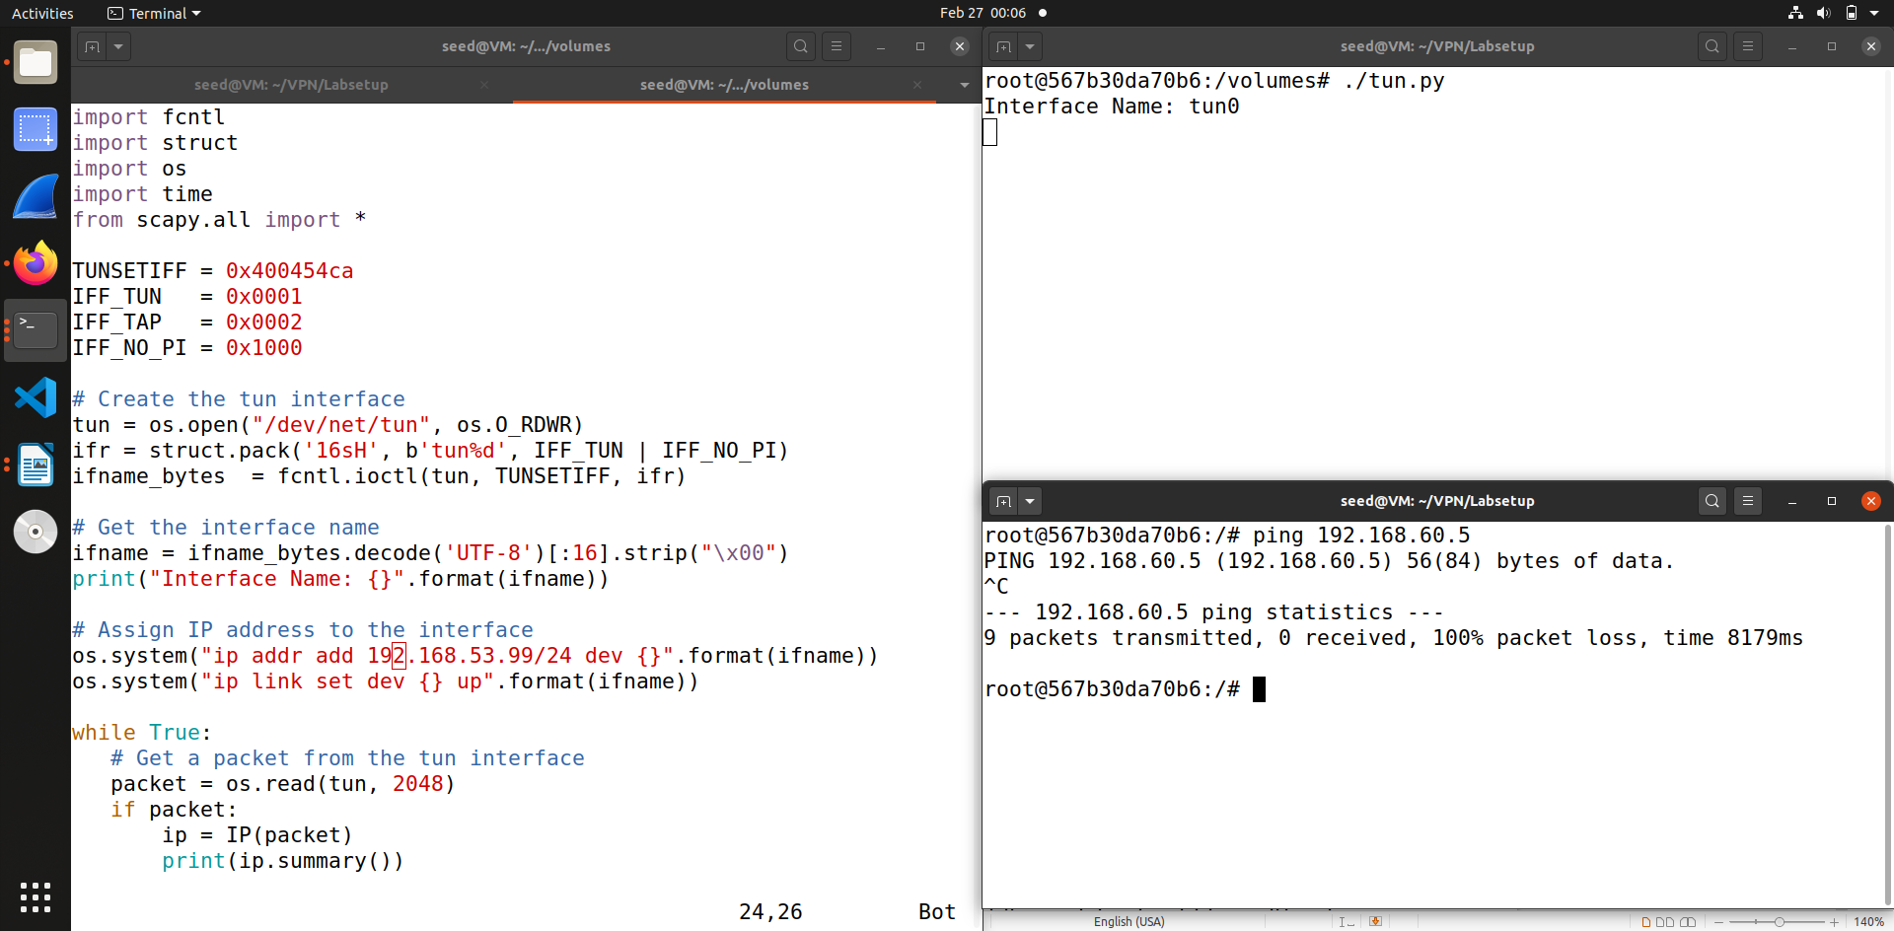Now when I try to ping a host in the internal network – 192.168.60.5/24, in the above screenshot you can see I pinged 192.168.60.5 but in the tun interface it shows nothing as the address is not in the network.

**Task 2.d : Write to the TUN interface**

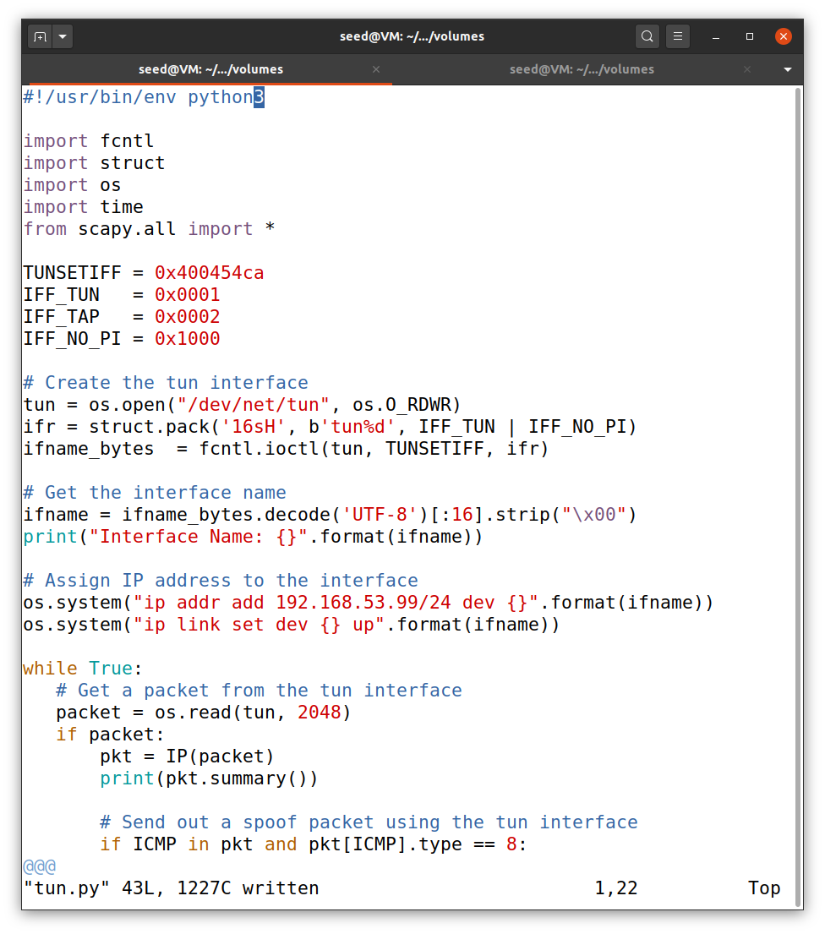

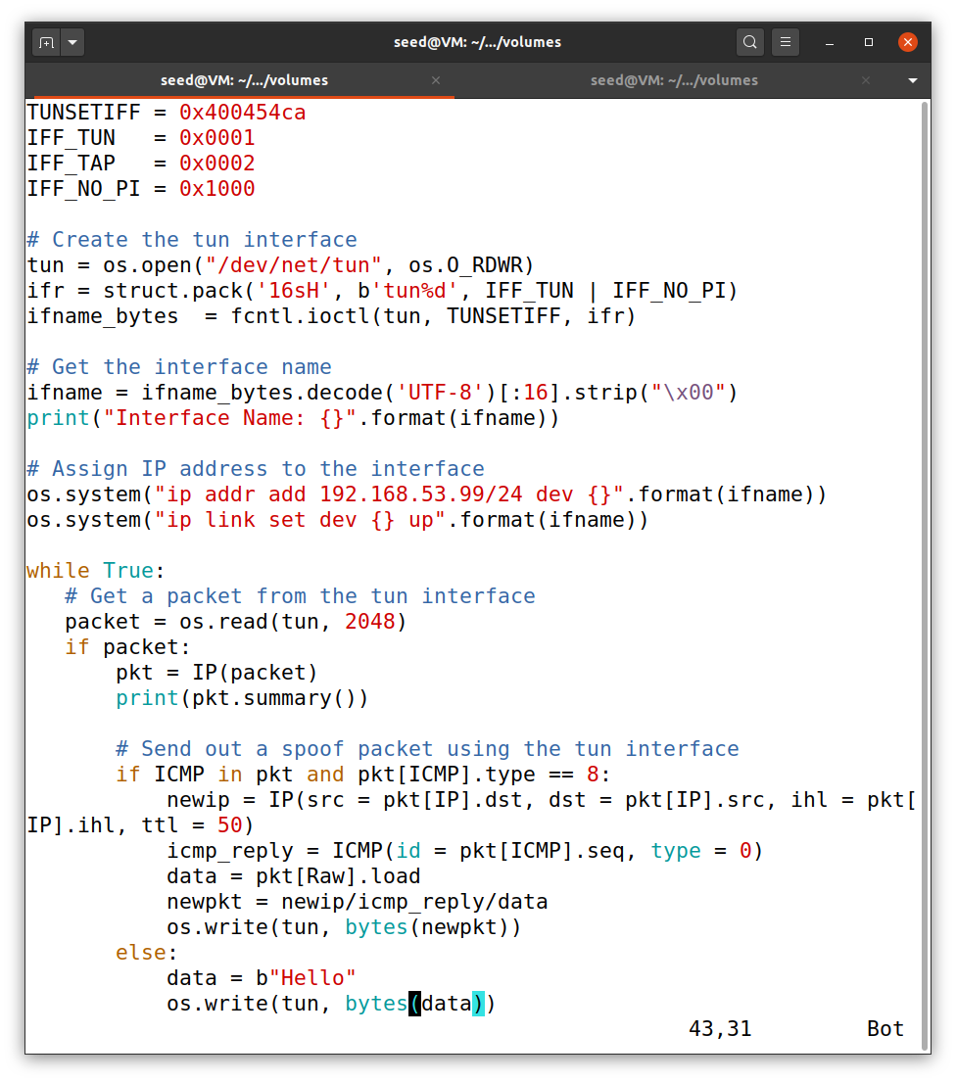In this task we write to tun interface, to this we need to modify the code, so this screenshot contains the modified code.

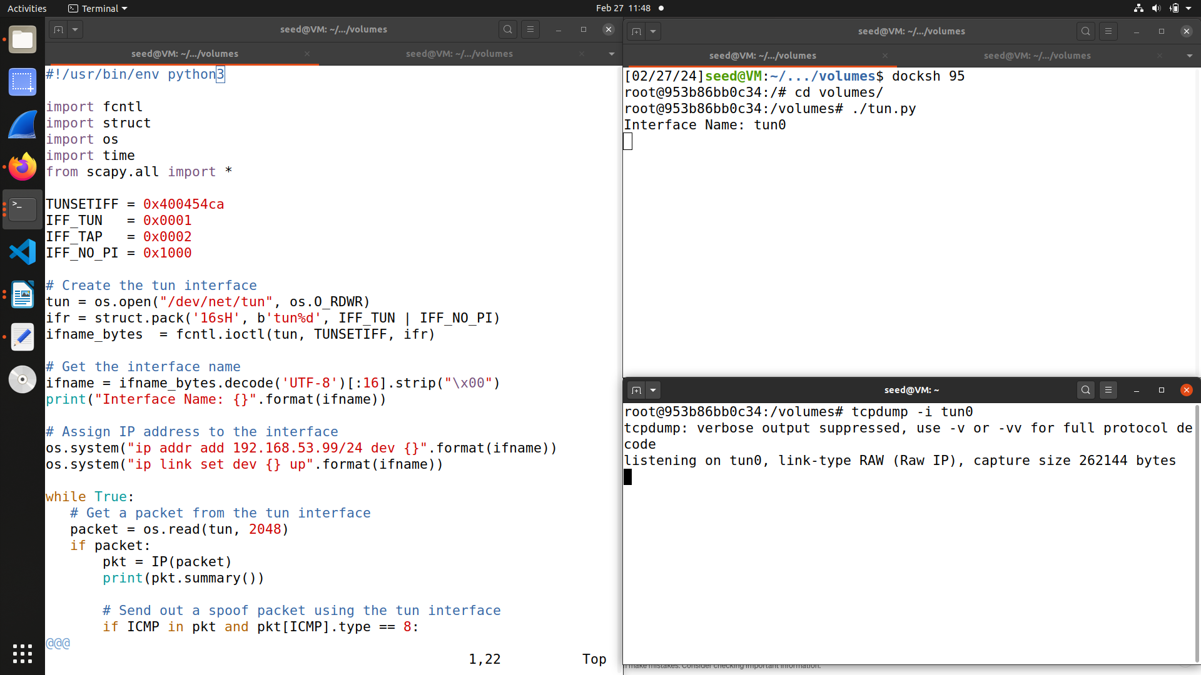

Now in this task we run the program and then do tcpdump on the interface as shown in the above screenshot

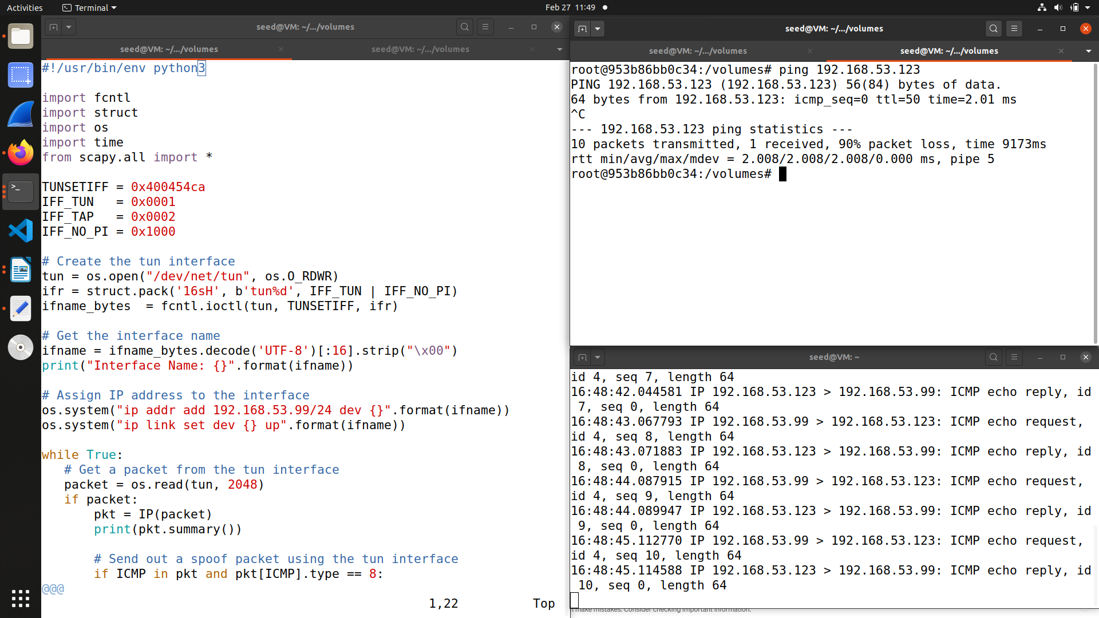So test this , we ping and telnet to any IP address in the internal network of 192.168.53.0/24, so as shown in above screenshot I have pinged 192.163.53.123.

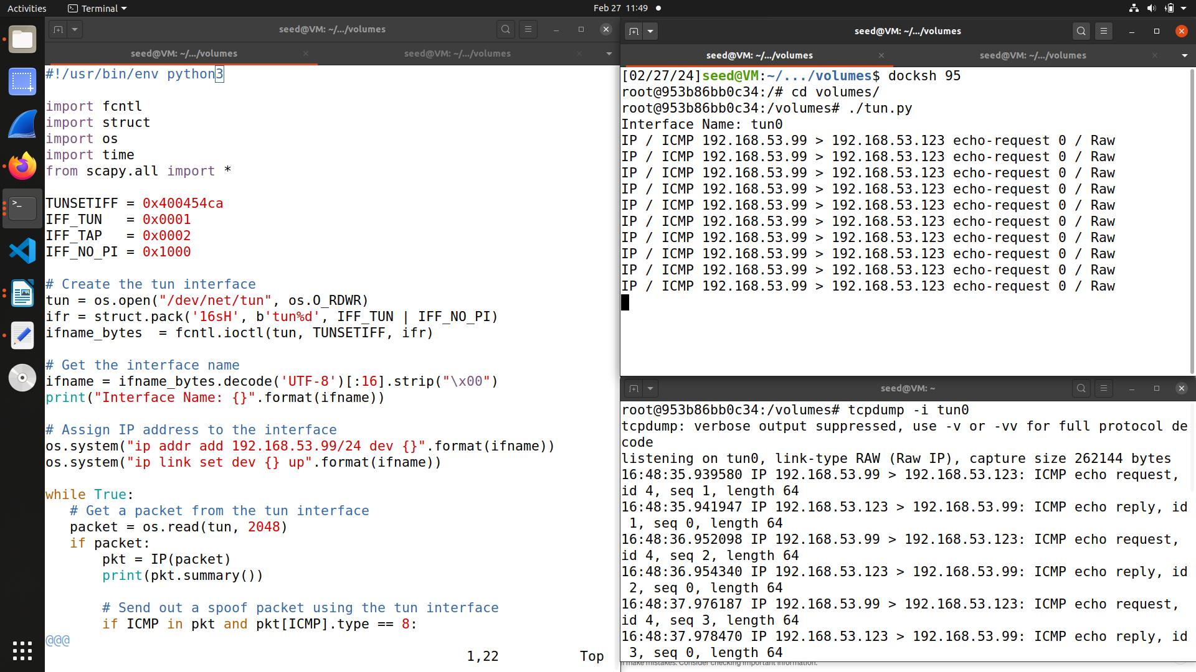From the above screenshot we can see that when we pinged 192.163.53.123, the tun0 captures as we have linked it to the code and it send a reply back and in the tcpdump also we can see the packets getting captured.

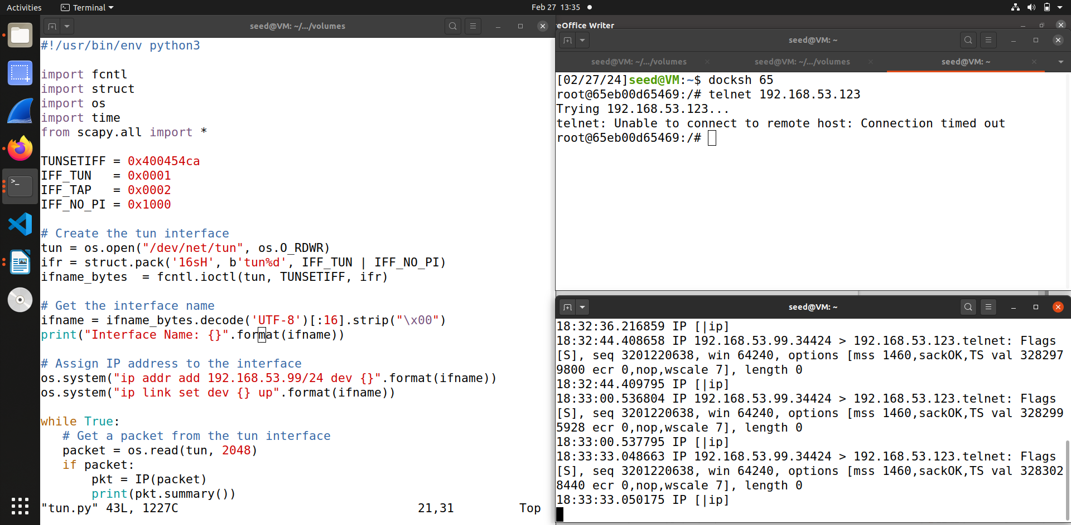When I try to telnet 192.168.53.123, it is not able to connect.

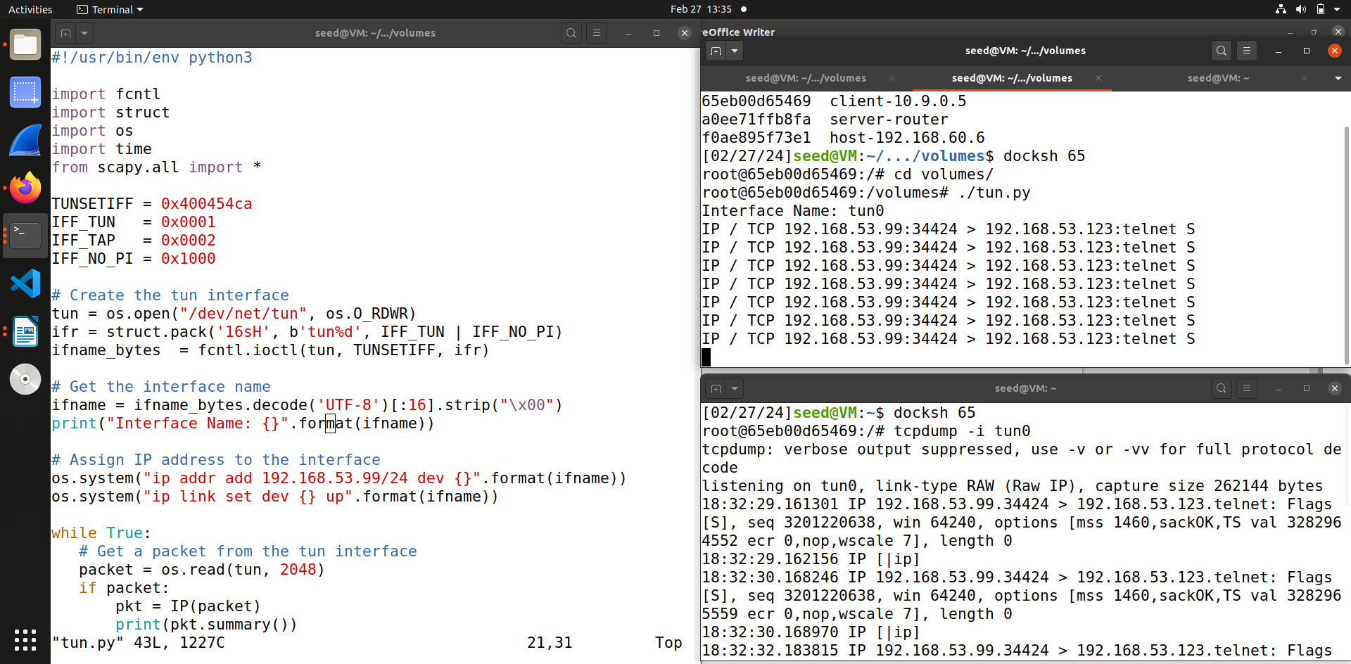  
From the above screenshot you can see that the tun0 interface captures it because we have linked it in the code. And then it write backs the data we wrote in code as an IP packet in response. In the tcpdump section it also shows the packets getting captured .

**Task 3 : Send the IP Packet to VPN Server Through a Tunnel**

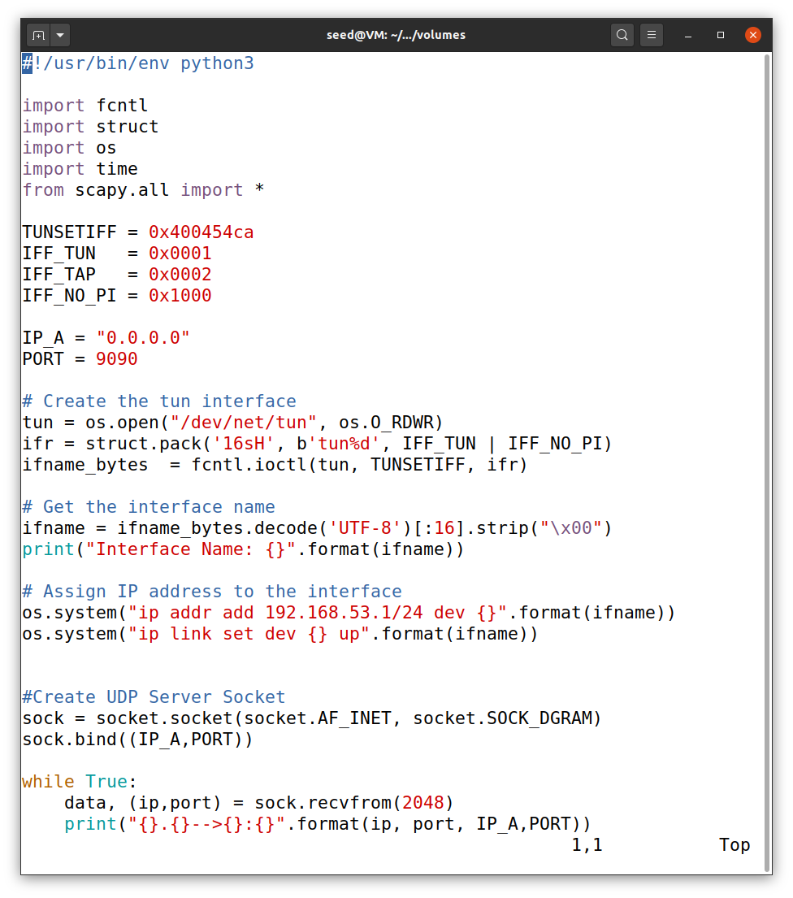

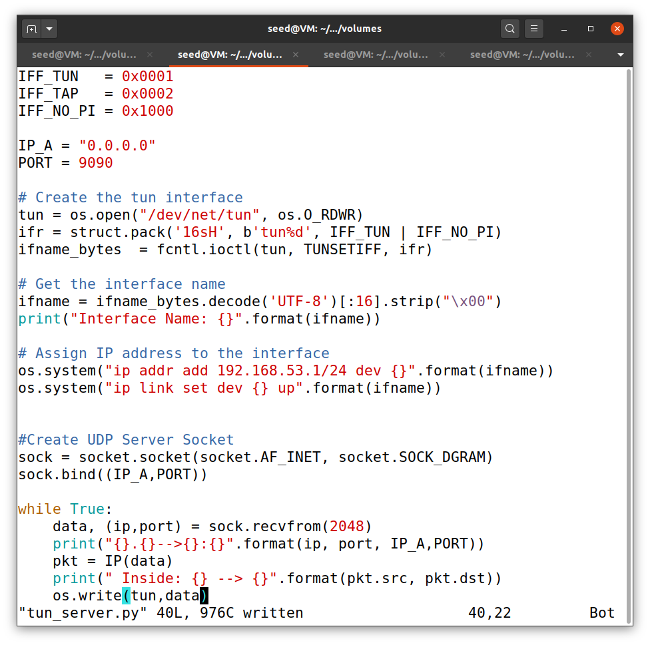In this task we set the TUN server and TUN client. This is server program – tun_server.py

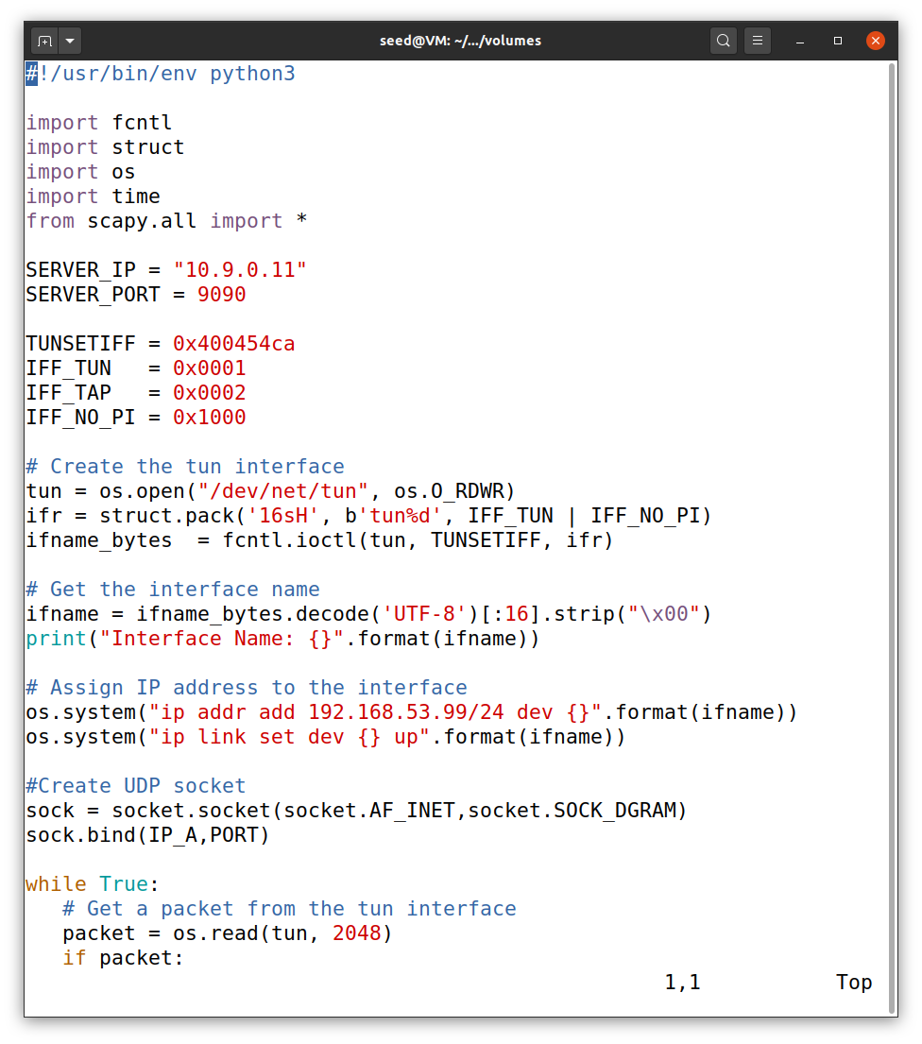

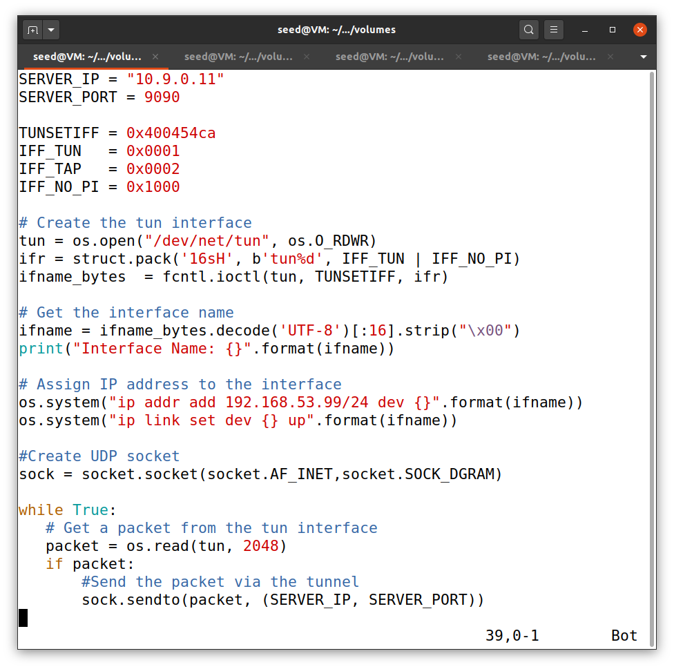This is the client program. - tun_client.py

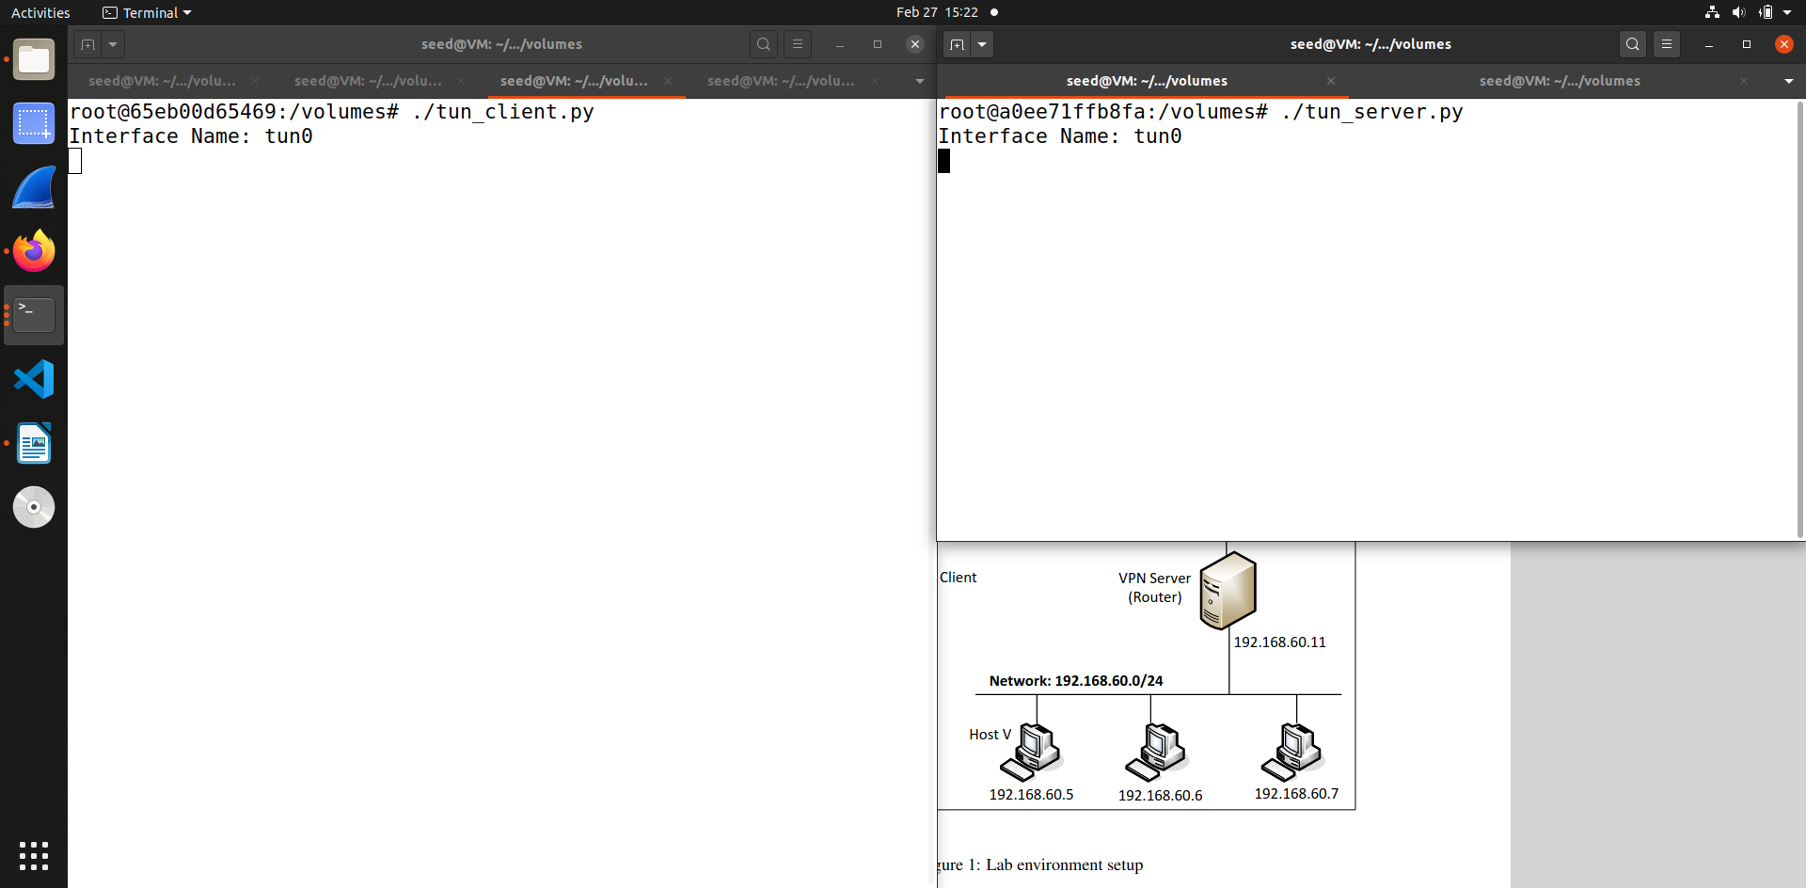So first we run the server program on VPN – server – 10.9.0.11 and client program on host U – 10.9.0.5

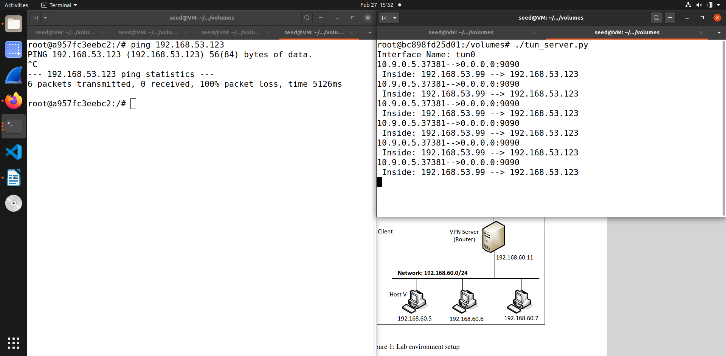Then after than we ping in internal network of 192.168.53.0/24 from host U – 10.9.0.5 and see what happens.

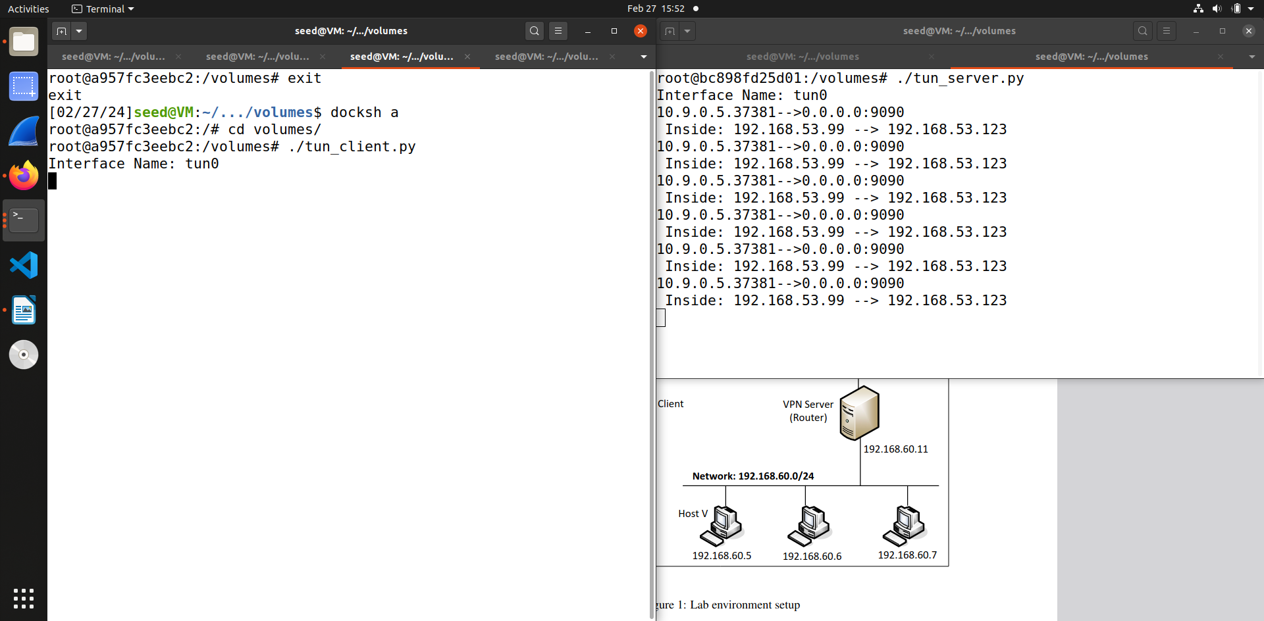So as you can see from this screenshot and the previous one that it shows up on the server side but nothing is there on client interface, this is because we print the summary in server program.

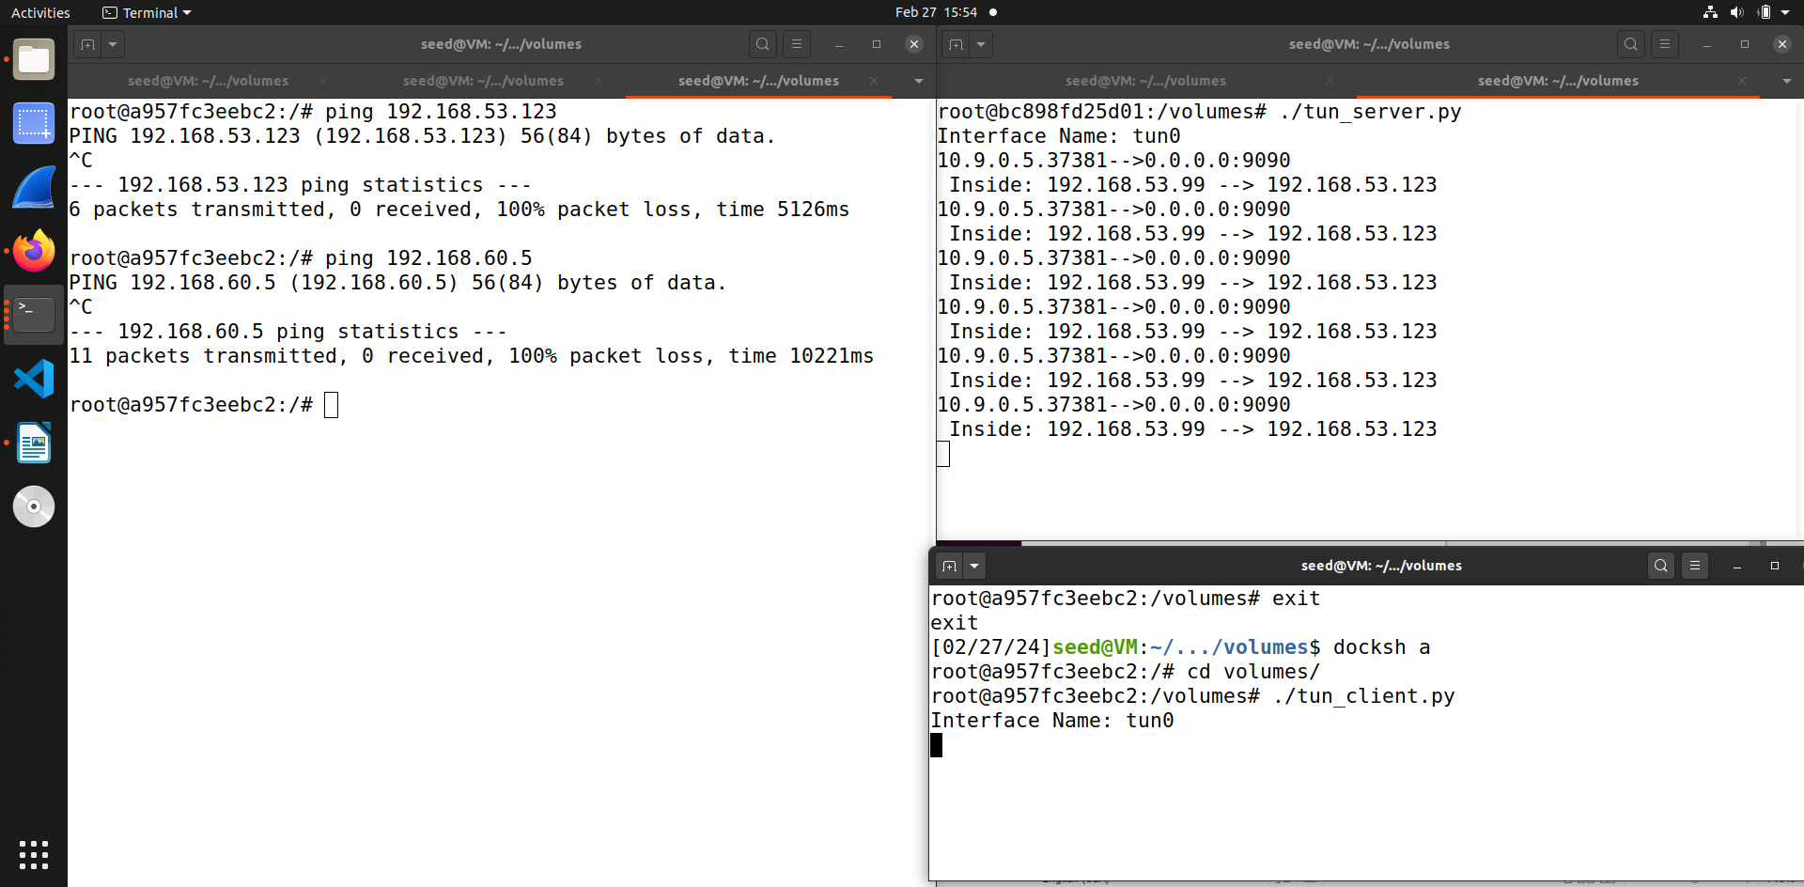  
When I try to ping host V – 192.168.60.0 and check whether it goes through and does it appear on client and server interface.

As you can see from the screenshot it shows nothing on both interfaces so this means we can’t still access host V from host U. To solve this we need to use routing to add a route from this network to the TUN interface, which we will do using ip route command.

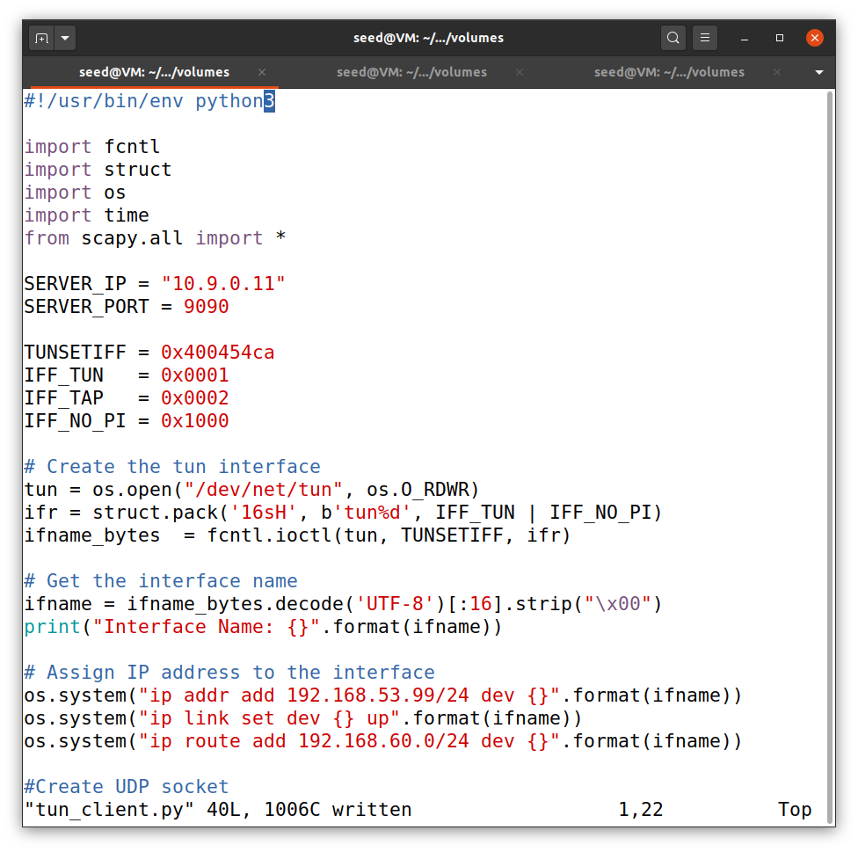This is the change we add in the tun_client.py program. So we add -

os.system(“ip route add 192.168.60.0/24 dev {}”.format(ifname))

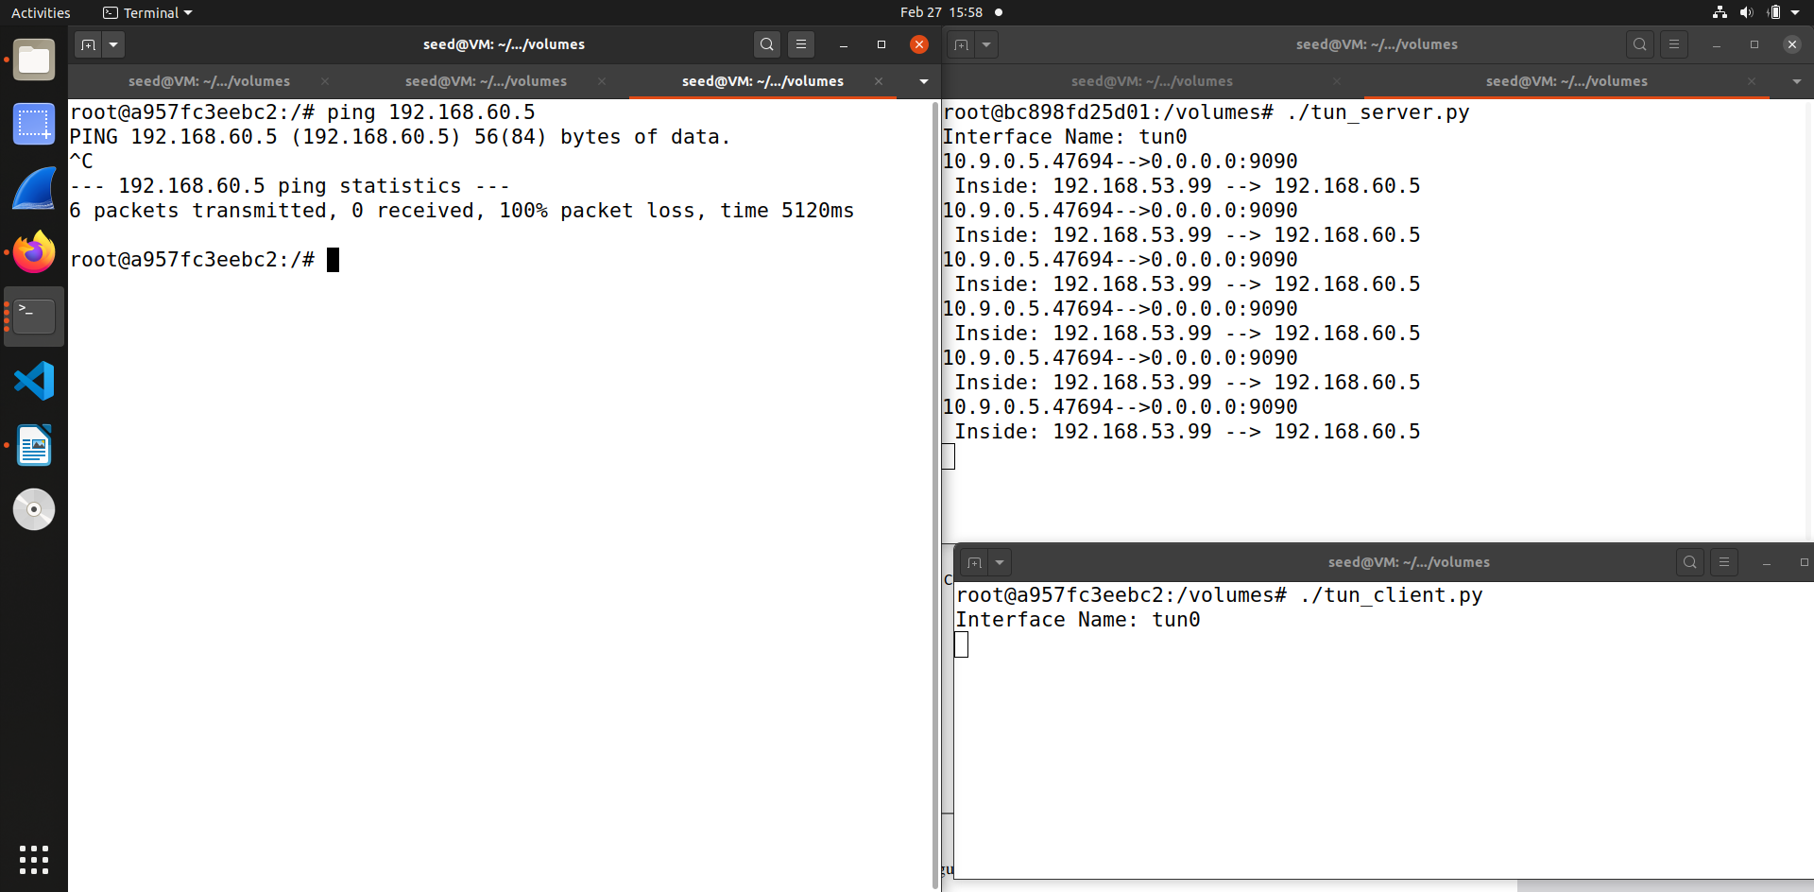So after doing that change and running once again both the client and server program and then ping 192.168.60.5 we can see that the ICMP packets go through the server program and is visible in the interface.

**Task 4 : Set up the VPN Server**

So I already made the changes required for this code in the previous assignment, so I am not putting screenshot of the codes.

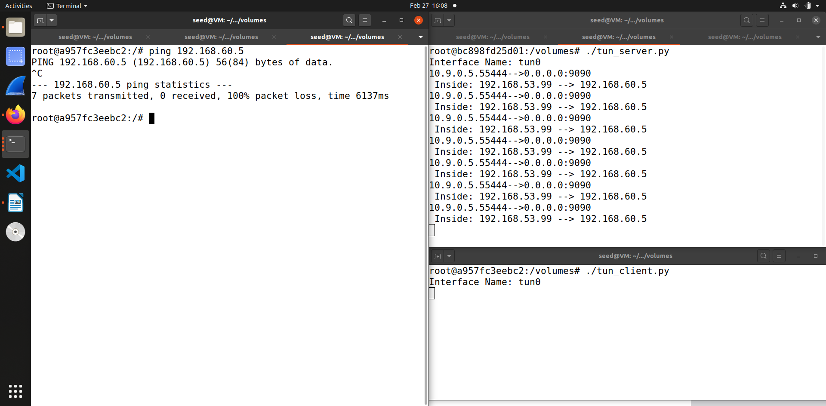When I try to ping 192.168.60.5 from host U -10.9.0.5 we can see that the ping fails and nothing appears on the client interface whereas it shows on the server interface that mean it reaches the tun_server

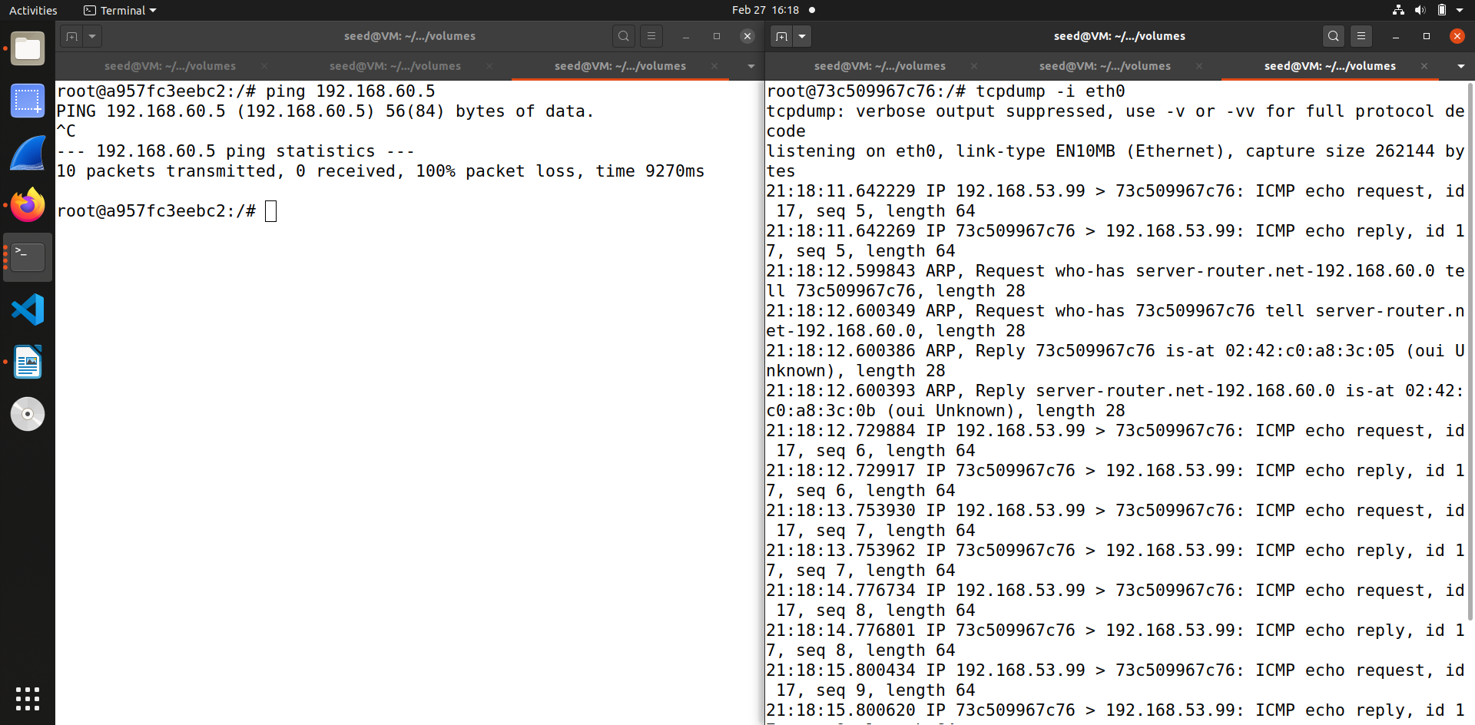In the tcpdump screenshot aslo we can see the packets getting captured on eth0.

**Task 5 : Handling Traffic in Both Directions**

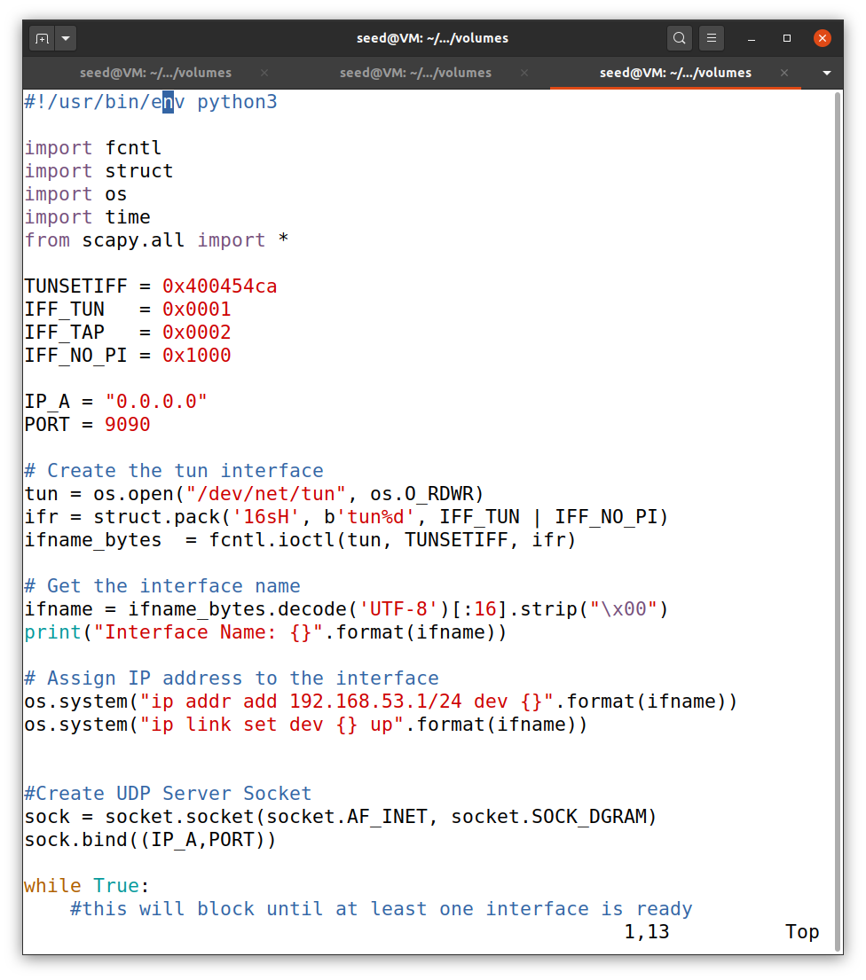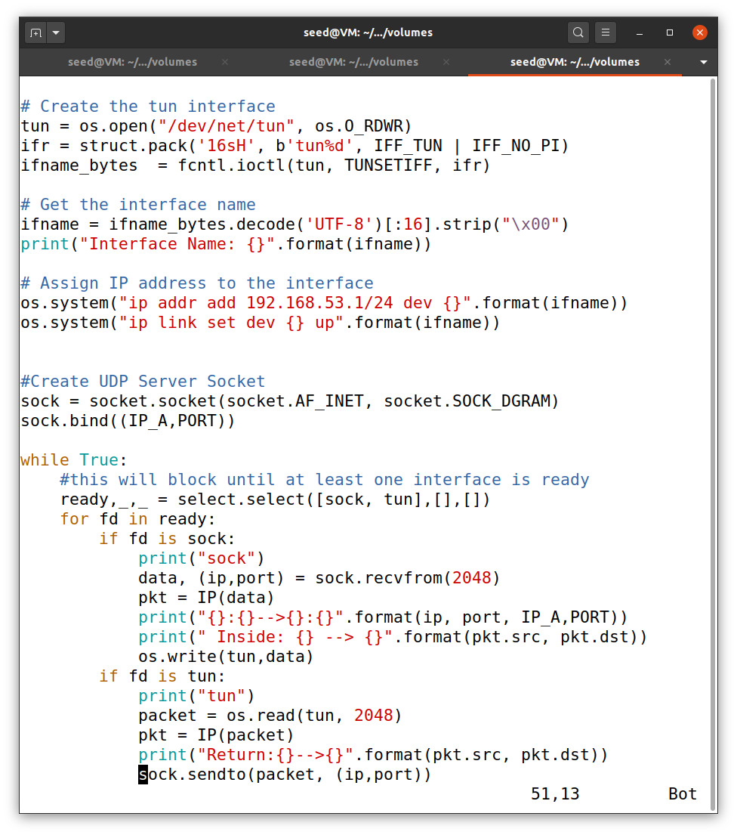So for this task we modify both server and client program and add for loops in both programs. This is screenshot of tun_server.py program.

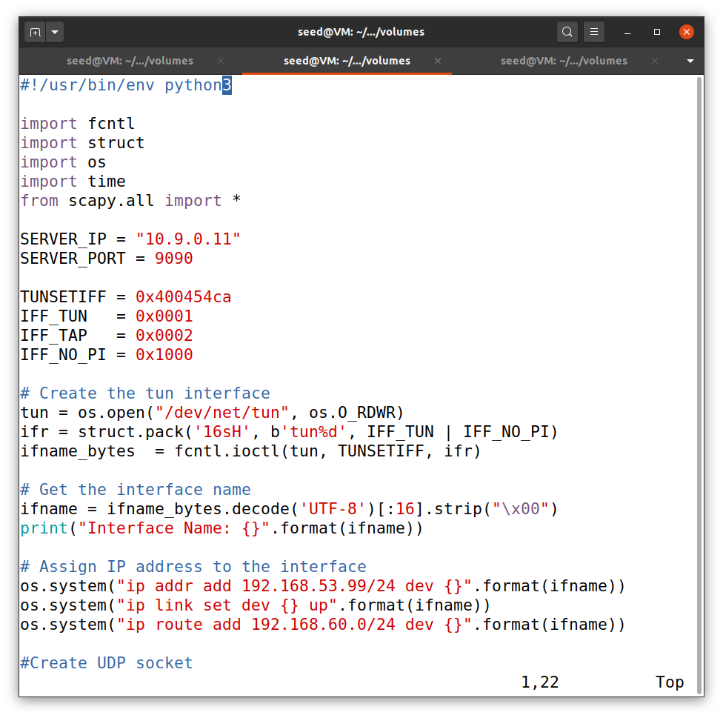

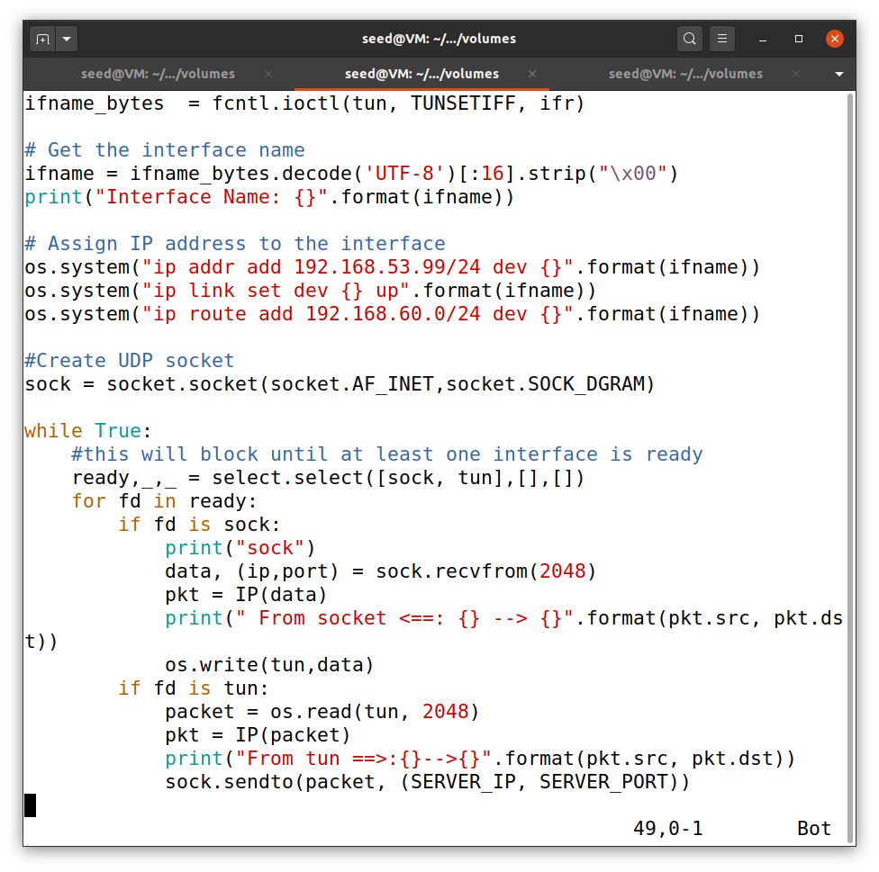

This is modified code for tun_client.py

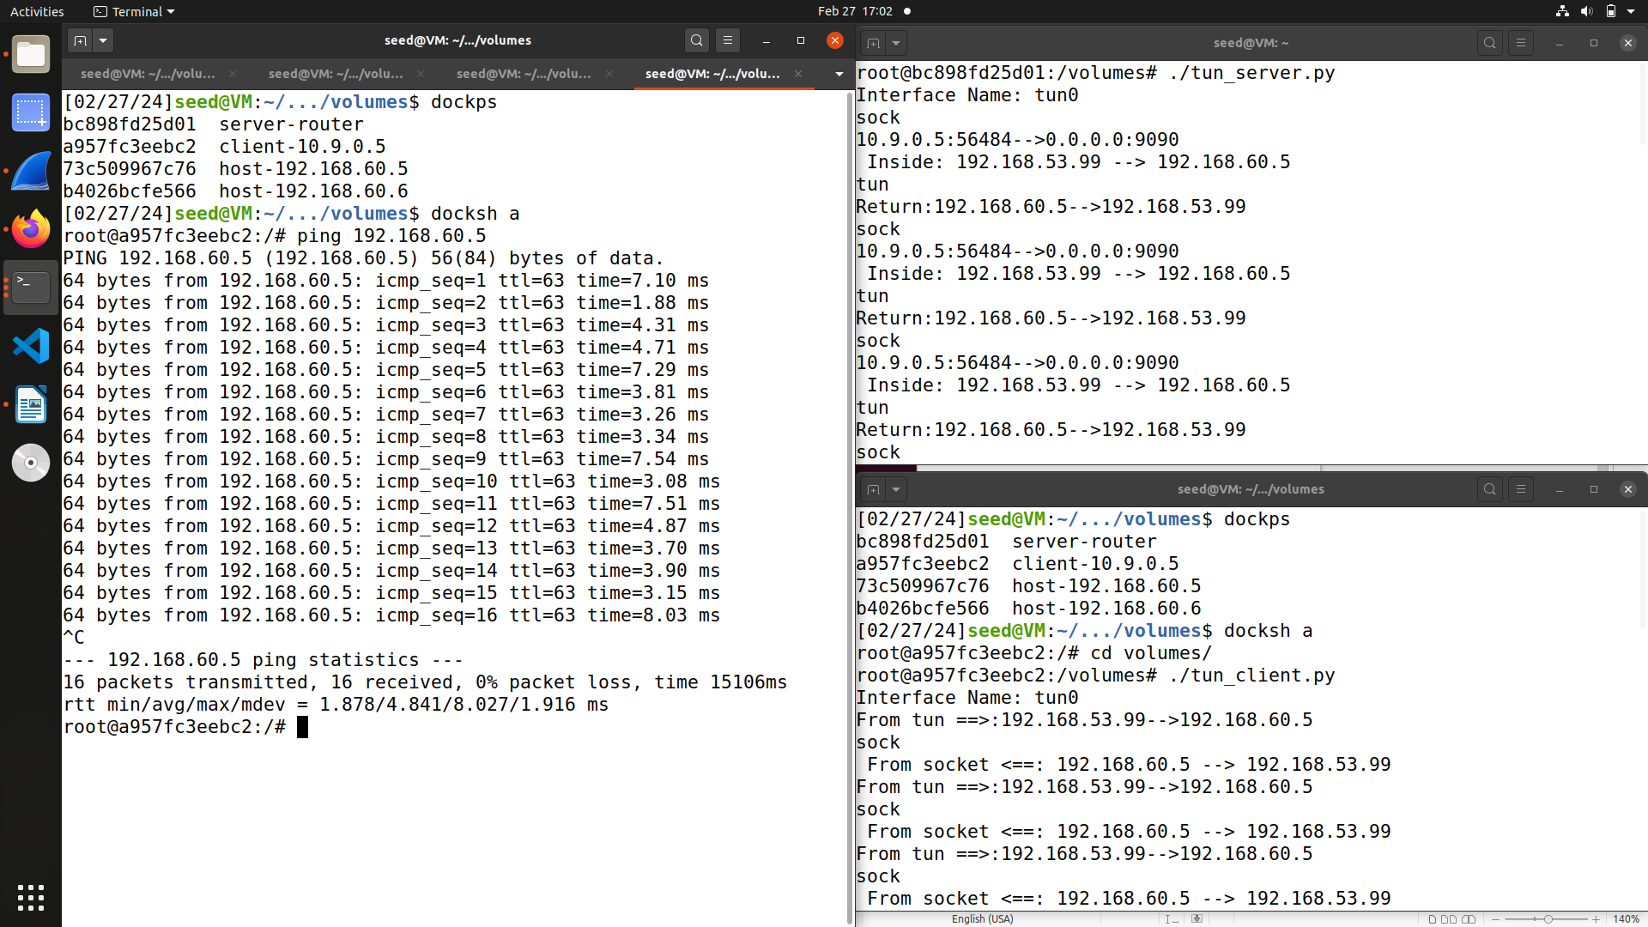

Now we run both the programs. And then we ping 192.168.60.5 and also record the traffic on wireshark.

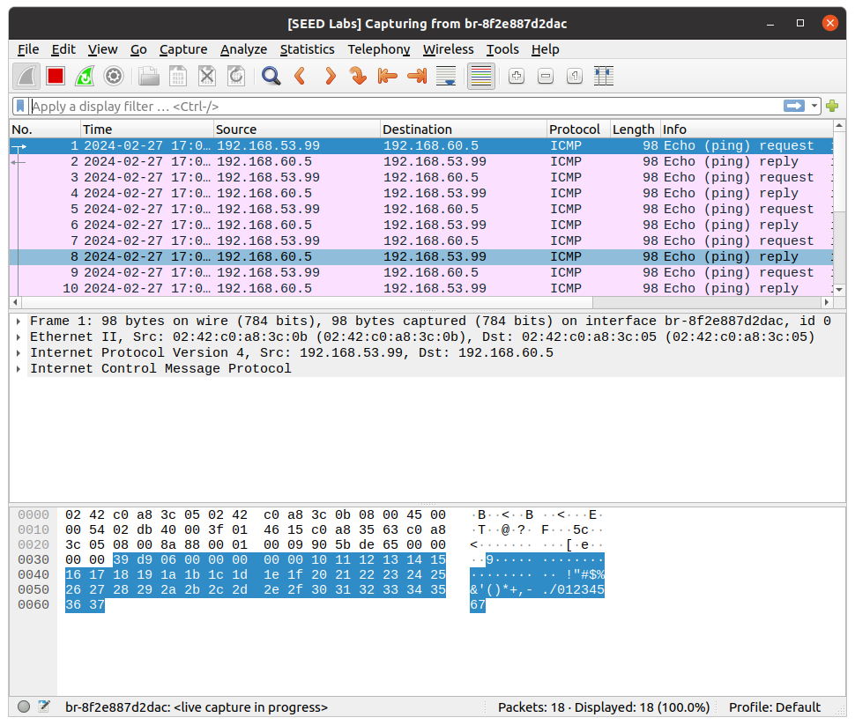

As you can see from both the screenshots that now host U – 10.9.0.5 is now able to communicate with 192.168.60.0 via ping as we have set up connection between host V- 192.168.60.5 and the server – 10.9.0.11 and also between another server and host U.

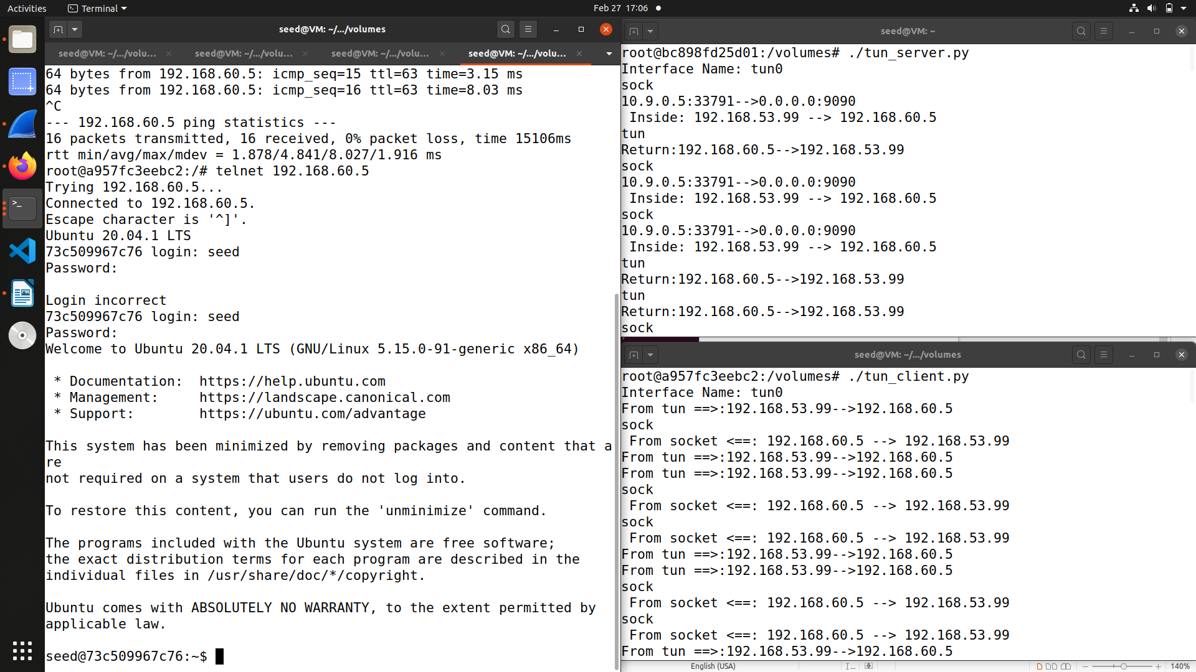

Now we try to telnet host V – 192.168.60.0 from host U – 10.9.0.5 and as you can see from the screenshot this is also successful and host U is able to telnet successfully as we have set up connection between them.

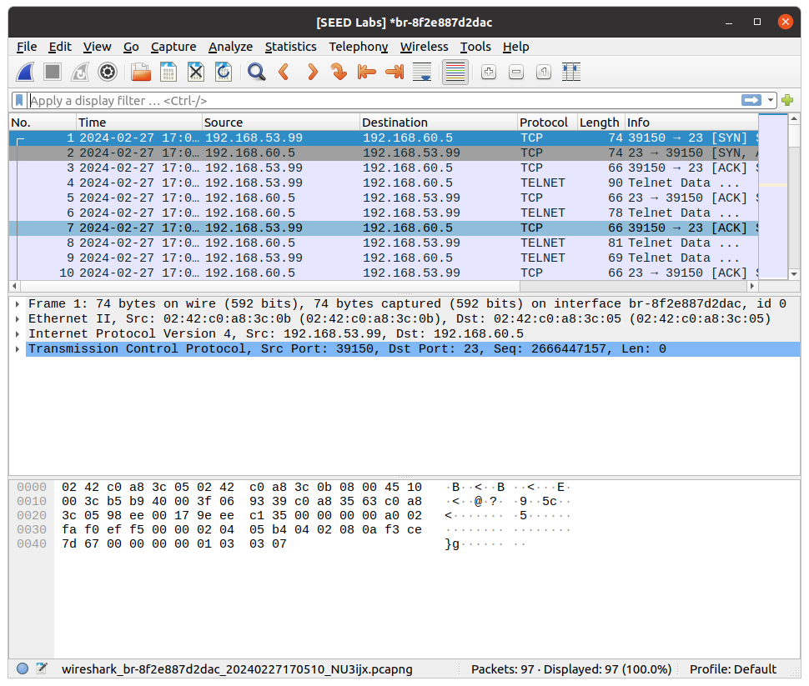We can also see the wireshark output which shows the packet getting captured and telnet is successful.

**Task 6 : Tunnel-Breaking Experiment**

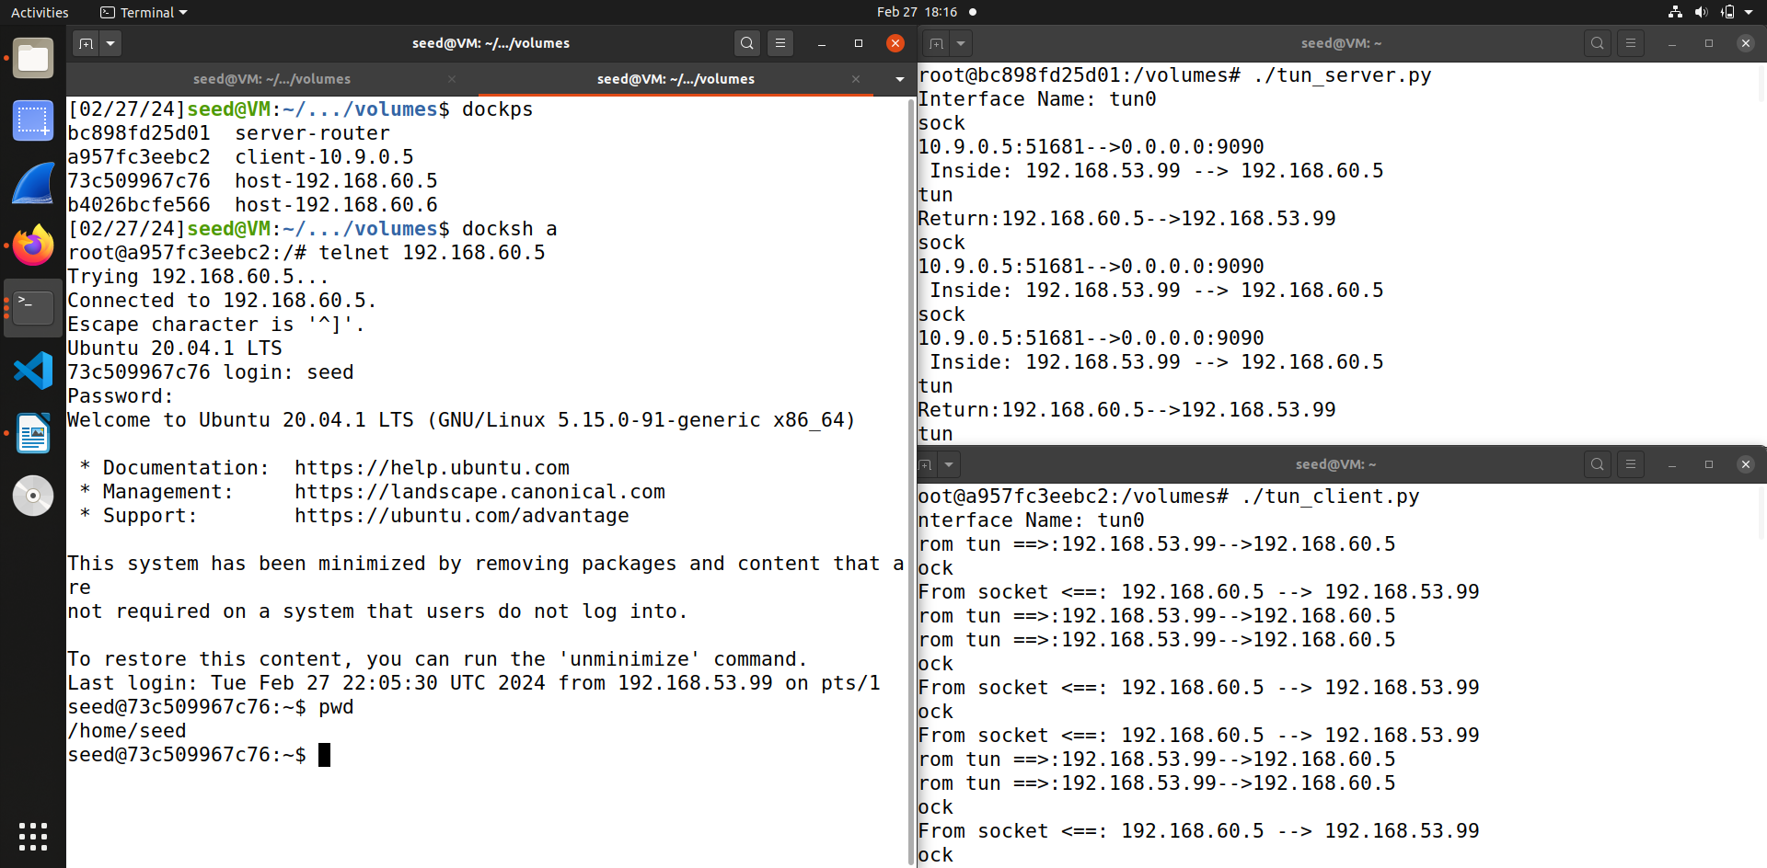First we run the server and the client programs on server machine and client machine respectively. After that we telnet to host V -192.168.60.5 from host U – 10.9.0.5. As you can see from the screenshot the connection is successful.

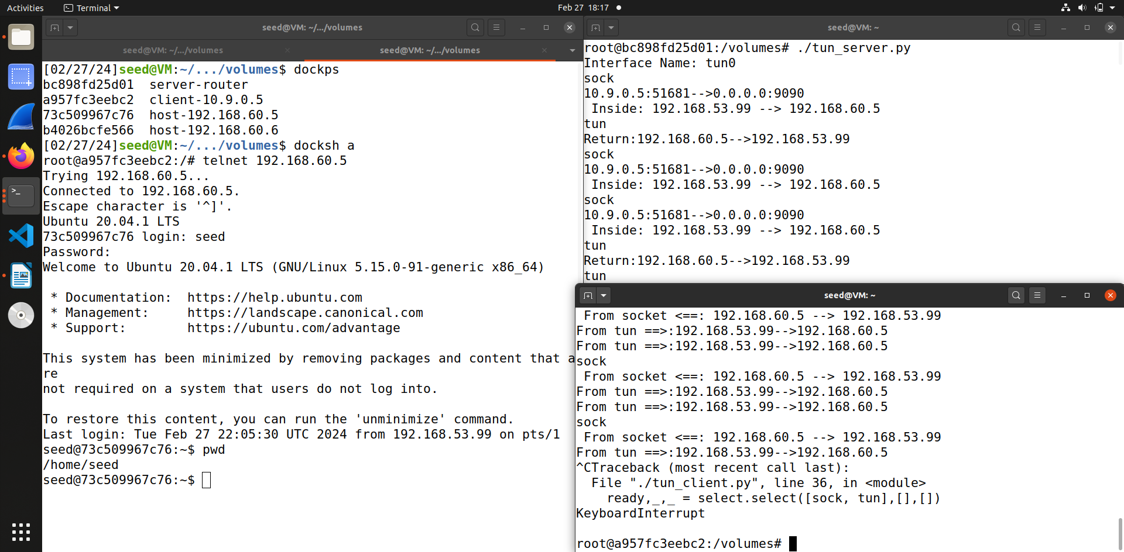 Now we type command in the telnet connected terminal of 192.168.60.5, as you can see from screenshot I typed in pwd, but nothing appears in the client and server interface.

After that I broke the connection by stopping the client interface that is tun_client.py. Still nothing shows up in the telnet window or in server interface. After that I try to type in telnet connected terminal.

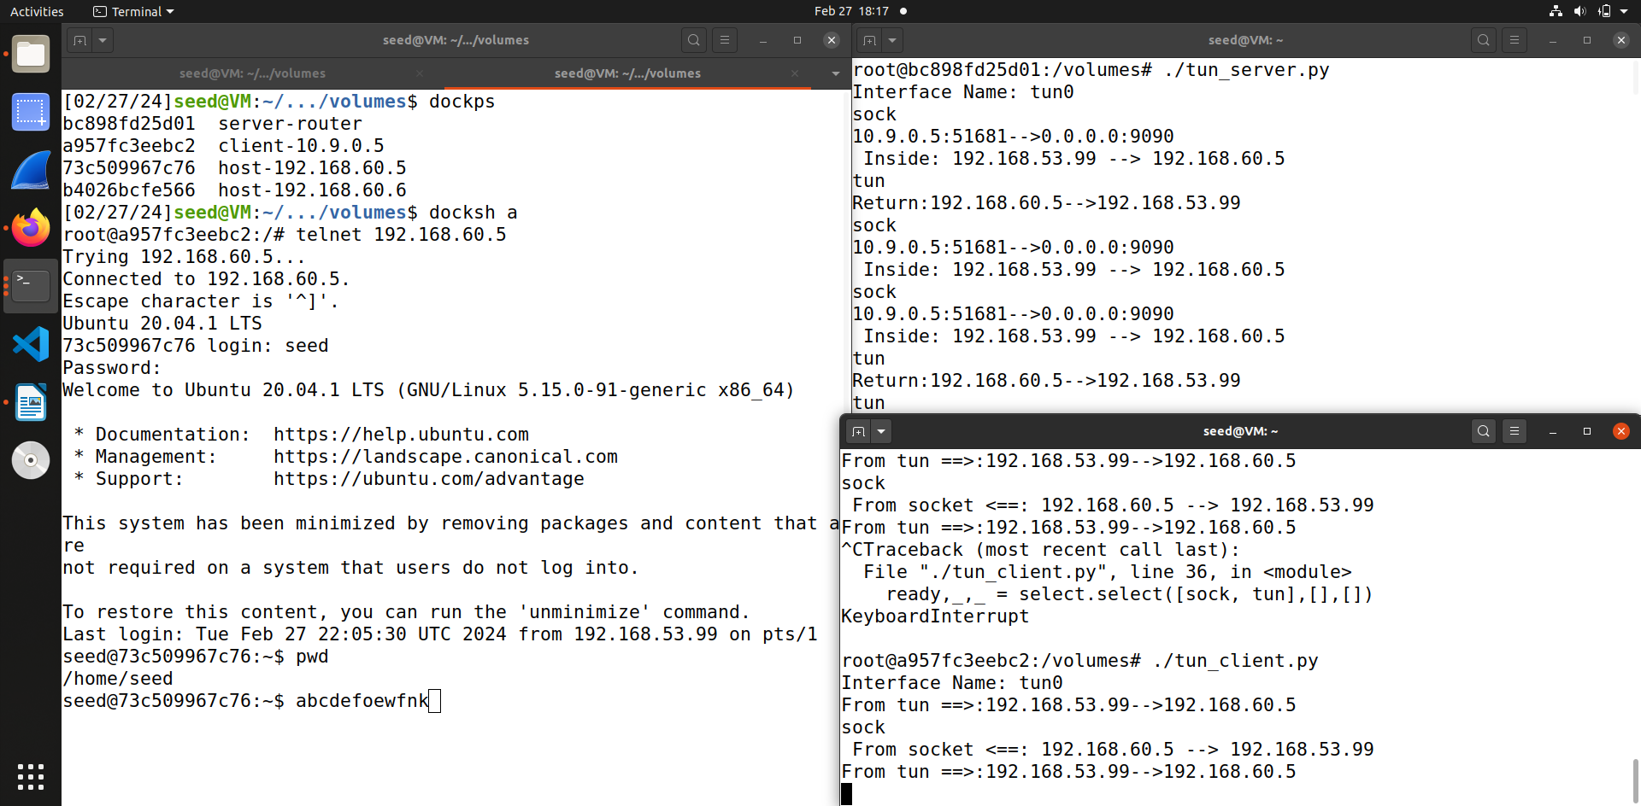When I reconnect the connection of client interface, we can see that whatever I had typed in the telnet connected window appears . Thus we have successfully conducted the tunnel breaking experiment.

**Task 7 : Routing Experiment on Host V**

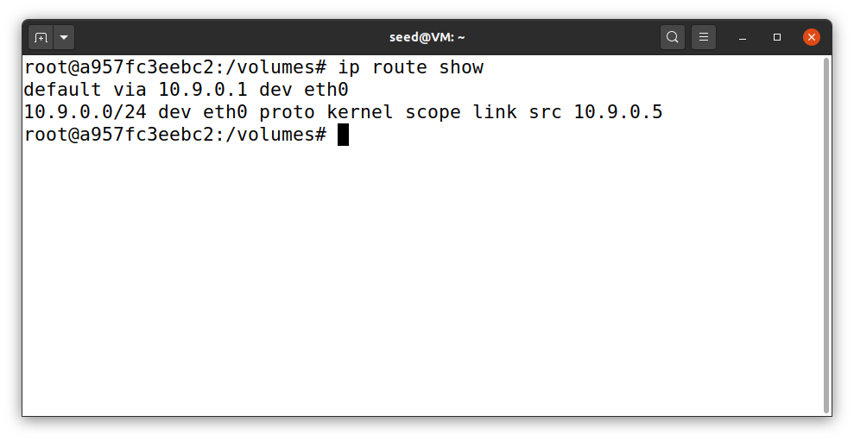So for this task first we look at the default route looks like. I firstly docksh in host U – 10.9.0.5 and then check the route by executing command ip route show.

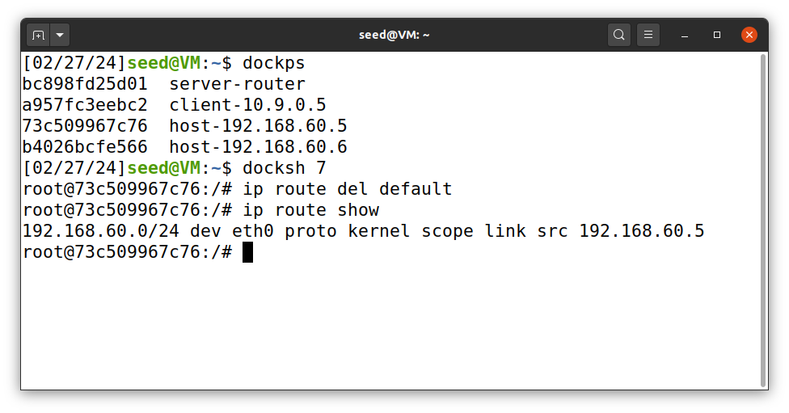After that the next step is to delete the default route. So for that I docksh in host V – 192.168.60.5 and then delete the default route using the command – ip route del default, then check the route again which shows nothing.

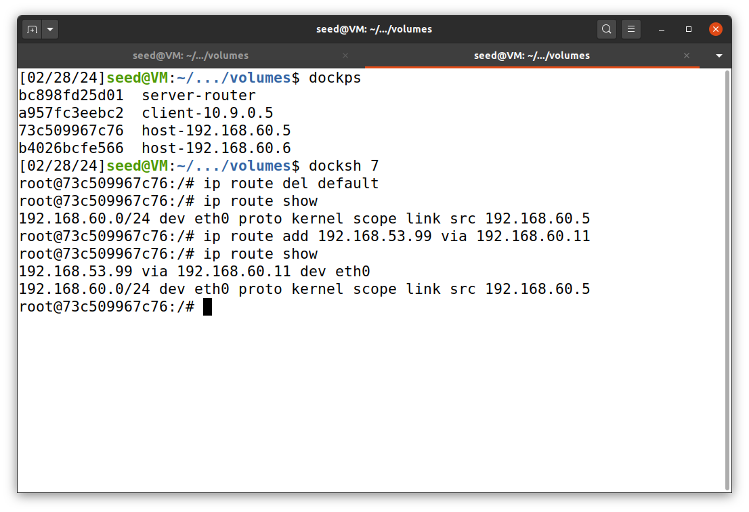Then I added the custom route which you can see in the above screenshot.

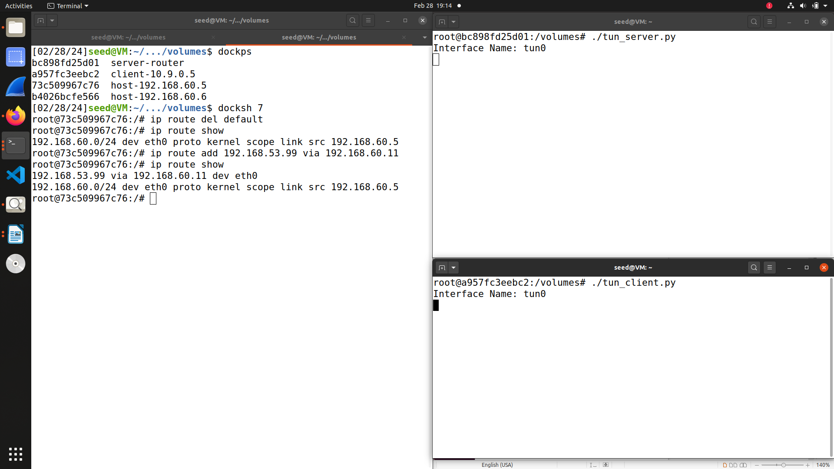After that I once again start running the tun_server and tun_client programs as you can see from the screenshot

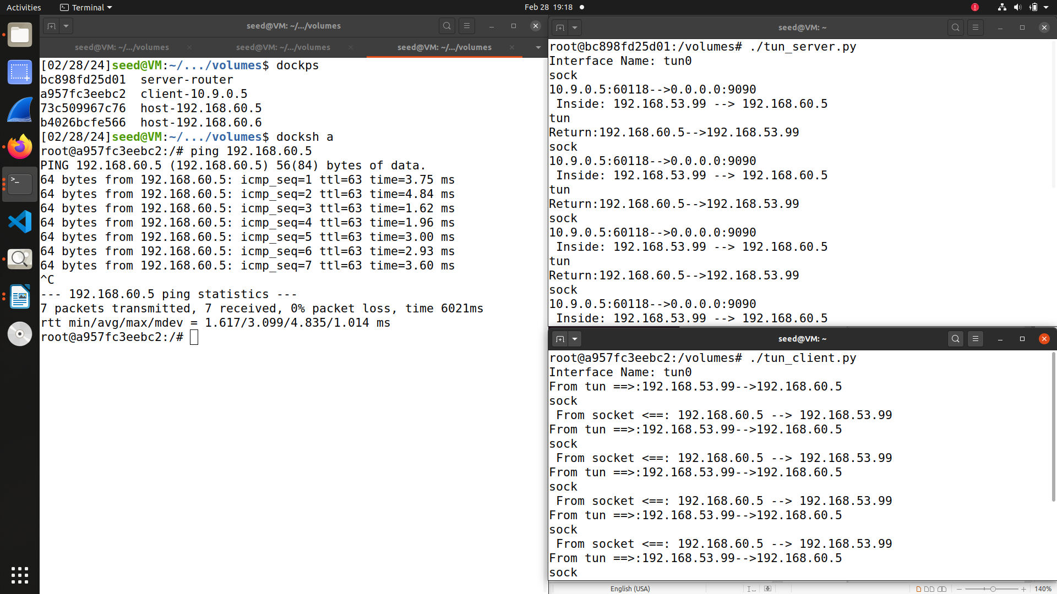Then I ping host V – 192.163.60.5 from host U – 10.9.0.5 to see if the route works. This works as we can see from the above screenshot. Thus we have successfully completed the routing experiment.